CLAIM/COUNTERCLAIM STATEMENTS:
- Although______________________________________, a stronger argument is______________________________.
- Even though ________________________________, what is more convincing is ______________________________.
- ____________________________________________ may be true yet ______________________________________.
- It has been noted that______________________________ and yet _________________________________________ is also true.
- While it might be true that________________________, still all in all _____________________________________.
- Some may say that______________________________, yet its debatable/arguable because ___________________.
- It may be true that _________________________, however ________________________________________.
- While some research shows ________________________, nevertheless ____________________________________.
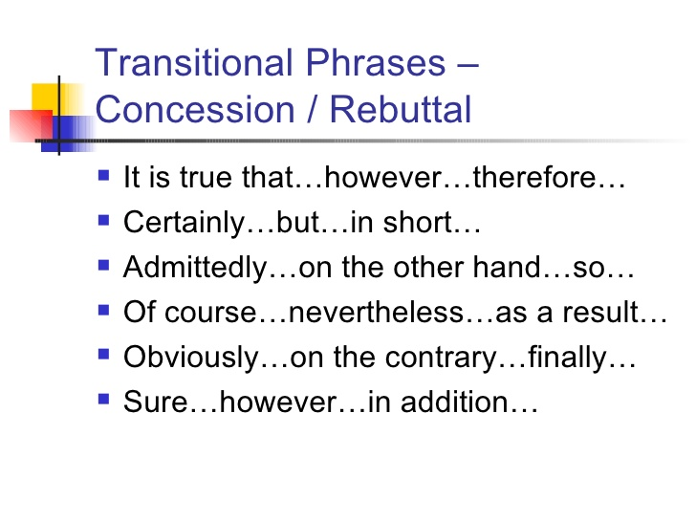
KEEP IN MIND:
Counterarguments can usually be done with three distinct techniques:
1. Providing contradictory evidence
2. Exposing a logical fallacy
3. Uncovering alternative motivations.
1st paragraph:
- Make one or two general sentences about the topic
- Then briefly summarize/introduce what the argument is about
- Make sure that your thesis is the last sentence in the introduction
- YOUR THESIS MUST BE CLEAR AND SHOW WHICH SIDE YOU ARE ON AND HAVE AT LEAST 2-3 REASONS WHY YOU BELIEVE THIS WAY…..BUT THOSE REASONS NEED TO BE BRIEF!!!!!

2ND and 3rd paragraphs:
- You will use evidence to back up your argument YET you will use the COUNTERCLAIM FIRST, then refute it with your STRONGER ARGUMENT!!!!
- You will go back and forth between what the other side says and then ALWAYS refute it with your STRONGER ARGUMENT!!!
- You will do this over and over in the body paragraphs

Final paragraph/conclusion:
- Wrap up and restate your argument
- Connect to today the importance of the argument

INTRODUCTION:

- Start with a general sentence about the topic

(Example: technology, Olympics)

- Write another sentence about the topic

- Next write how this topic is controversial
(Example: Gathering information without people’s knowledge is a controversial topic)
- Then write what the argument is
(Example: Some feel gathering information without customer knowledge is wrong while others feel it is okay)

- Lastly write your thesis statement and MAKE SURE YOU HAVE REASONS WHY……..as these become your body paragraphs

CONCLUSION:
- Restate your thesis statement with words such as: “clearly”, “obviously”, etc.
(Example: Clearly, having information taken without knowledge seems like an invasion of privacy.)
- Restate how or why this is a controversial topic
(Example: Gathering information without people’s knowledge is a controversial topic)
3. ***These first two sentences can be switched in order****
4. Connect to today’s world, connect to people everywhere, and connect to importance of topic

