Name__________________________________
The Exorcist Discussion Questions
Directions: Answer the following questions in short paragraph form.
1. According to Entertainment Weekly, The Exorcist is the scariest film of all time. Do you agree? Why or why not? Please use specific evidence from the film to support your response.
___________________________________________________________________________________________________________________________________________________________________________________________________________________________________________________________________________________________________________________________________________________________________________________________________________________________________________________________________________________________________________________________________________________________________________________________________________________________________________________________________________________________________________________________________________________________________________________________________________________________________________________________________________________________________________________________________________________________________________________________________________________________________________________________________________________________________________________________________________________________________________________________________________________________________________________________________________________________________________________________________________________________________________________________________________________________________________________________________________________________________________________________________________________________________________________________________________________________________________________________________________________________________________________________________________________________________________________________________________________________________________________________________________________________________________________________________________________________________________________________________________________________________

2. The Exorcist contains some uniquely unsettling sound effects. As the film progresses, for example, Regan's voice morphs into an elaborate sort of cacophony. It turns out that some of the sounds used to realize this were supplied by Blair, others by a voiceover artist called Mercedes McCambridge. Still more came from hundreds of other recordings of an array of diverse sounds, including croaking tree frogs, and bumblebees.
"William Friedkin and I had many discussions before filming," says Chris Newman, who was in charge of sound. "The big problem was that there's no common language to describe how Satan should sound. You could say, for example, 'who's an evil person?' and someone might answer 'Hitler!' but that doesn't mean you can give the Devil a German accent. Eventually, Billy came into a meeting with a book, and showed me that Hieronymus Bosch painting called “The Garden of Earthly Delights” (below). And he pointed at all the little characters in the picture, and there are dozens of them, and said: 'that's what the voice of Satan should sound like'. In many ways, with what we ended up doing, I think it does."
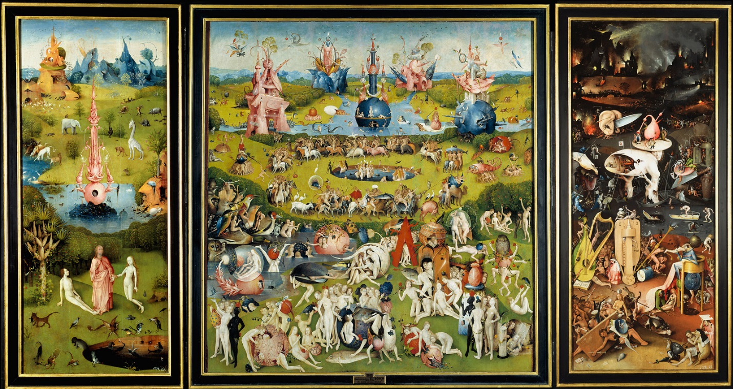
Diections: Choose ONE scene and explain how the use of specific sound effects sets the tone and/or mood of that scene. What effects are these sounds meant to have on the viewer? ___________________________________________________________________________________________________________________________________________________________________________________________________________________________________________________________________________________________________________________________________________________________________________________________________________________________________________________________________________________________________________________________________________________________________________________________________________________________________________________________________________________________________________________________________________________________________________________________________________________________________________________________________________________________________________________________________________________________________________________________________________________________________________________________________________________________________________________________________________________________________________________________________________________________________________________________________________________________________________________________________________________________________________________________________________________________________________________________________________________________________________________________________________________________________________________________________________________________________________________________________________________________________________________________________________________________________________________________________________________________________________________________________________________________________________________________________________________________________________________________________________________________________________________________________________________________________________________________________________________________________________________________________________________________________________________________________________________________________________________________________________________________________________________________________________________________________________________________________________________________________________________________________________________________________________________________________________________________________________________________________________________________________________________________________________

