FISHBOWL ACTIVITY
Name__________________________________
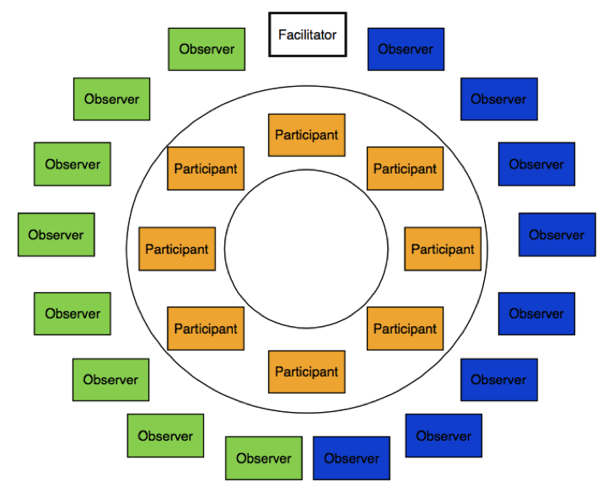
Fishbowl Articles & Discussion Instructions:
Topic: Is man’s basic nature inherently good or evil?
You will work with your partner within your pre-assigned groups in order to complete the following tasks (so in a group of four, two people will work together to address one side of the argument while the other two people will collaborate on the other side):
Articles (approximately 2-3 class periods):
- Closely read and annotate the texts on the nature of humanity and identify the central ideas for each. You should also identify within each article the pros and cons of each side of the argument. I would suggest using different colored highlighters or pencils to do this.
- Using evidence from the texts, develop a claim/counterclaim regarding whether man is inherently good or evil. Be sure that the claim and counterclaim are two sides of the same coin. This should be written as one sentence. Provide evidence and details from the texts in order to support your argument.

Sample topic: Humans vs. technology in the workplace.

Ex. “Although the increased use of technology in the workplace can cause unemployment (COUNTERCLAIM), studies show that it can increase wealth, productivity, and efficiency; therefore, humans should be replaced by machines (YOUR CLAIM).”
-OR-
Ex. “Machines may increase productivity in the workplace (COUNTERCLAIM), but they will never be an appropriate substitute for human intelligence and ability (YOUR CLAIM).”
Fishbowl (one or two class periods):
- On the day of the fishbowl discussion, you will meet with your partners for a few minutes to go over the main points and details that you will use to defend your argument. These must come directly from the text.
- You will separate into the inner and outer circles. Two of the four group members will be on the inside, and two will be on the outside. You will decide with your partner who will speak and who will observe. Bring your articles with you.
- Those on the INSIDE of the circle – you will discuss your ideas with each other one point at a time. Please try to limit yourself to only using information from the articles, not your own personal opinions (we’ll get to those later). You must speak at least twice in order to receive full credit. The person who is speaking will call on the next person who wants to speak, and there is no talking out of turn. Your PURPOSE is to defend your own argument while poking holes/pointing out flaws in the other side of the argument. If one person reads information from an article and you want to add onto it, defend it, or argue against it, you must use the texts. *This is not a random sharing of facts; it is the ability to defend your argument in a logical order. You must identify the title of the article, as well as the page/paragraph numbers you’re getting your info from so that everyone can follow along.
- Those on the OUTSIDE of the circle – write both you and your partners’ names and claim/counterclaim at the top of your notes page. Your job is to observe and take notes on any main points discussed in the fishbowl, as well as any questions that you have about the information you heard.
Evaluation:
Inside circle – you will be assessed on the amount you participate as well as the specific content/details you use from the articles in order to defend your argument.
Outside circle – you will be assessed on the quality and number of notes that you take during the discussion.

For the Observer: Discussion Notes
Fishbowl topic: ____________________________________________________________________________________________________________________________________
Point #1:

Evidence:

Point #2:

Evidence:

Point #3:

Evidence:

Point #4:

Evidence:

Notes for any special questions, connections, or alternative points of view that your partner raised in the fishbowl:

Fishbowl Evaluation Form
Name:_______________________________
Role:________________________________

After the Discussion:
1. Formulate your own opinion based on today’s discussion:

2. What were your own personal strengths / the strengths of your partner throughout this process?

3. In what area(s) can you and your partner use some improvement?

4. Questions and/or topics for further investigation:

