Horror Film LINKS:
1. Origins
(Georges Melies – “The Devil’s Castle”): https://www.youtube.com/watch?v=uGKz-JYRmXo
(German Expressionist paintings): https://www.google.com/search?q=german+expressionist+painters&espv=2&biw=1024&bih=639&tbm=isch&source=lnms&sa=X&ei=ikxKVN-tDOfCsATtpYGwDQ&ved=0CAgQ_AUoAQ&dpr=1
(German Expressionist film stills): https://www.google.com/search?espv=2&biw=1024&bih=639&tbm=isch&sa=1&q=german+expressionist+films&oq=german+expressionist+fi&gs_l=img.1.0.0l2j0i24l8.83651.86412.0.87717.10.10.0.0.0.0.84.661.10.10.0....0...1c.1.56.img..0.10.661.wugTrteFcoI
(Role of women):
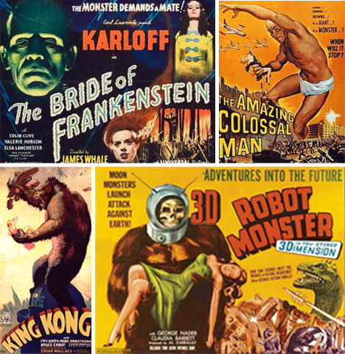
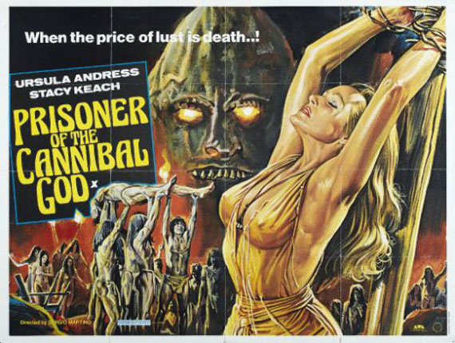
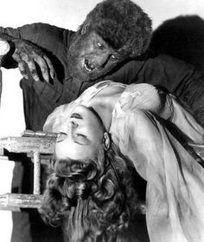
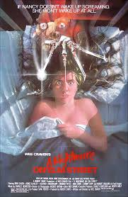
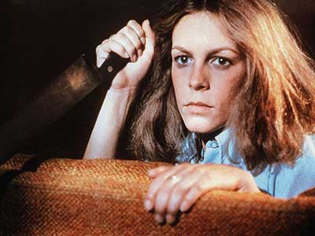
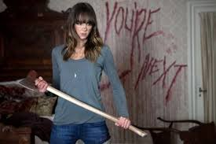

2. Score
Dracula 1931 - https://www.youtube.com/watch?v=kQQ7Jfo-fjg
Bride of Frankenstein 1935 - https://www.youtube.com/watch?v=YzJqNUOm030
Wolf Man 1941 - https://www.youtube.com/watch?v=nxK-ovs7ym4
Hammer Horror 1950s-1970s - https://www.youtube.com/watch?v=zF_M9msItIU
https://www.youtube.com/watch?v=udPstKu5XcM
Bernard Herrmann and Alfred Hitchcock’s Psycho 1960 - https://www.youtube.com/watch?v=qMTrVgpDwPk
The Exorcist 1973 - https://www.youtube.com/watch?v=geFhtD-ZXoA
Halloween - https://www.youtube.com/watch?v=Tq4GdBfLjsg
Insidious 2011 - https://www.youtube.com/watch?v=SOZROoCG6_4
a. lullaby melodies
Poltergeist - https://www.youtube.com/watch?v=TiNTy3YqczM
Devil’s Advocate - https://www.youtube.com/watch?v=xnK14ORAOk4
Rosemary’s Baby - https://www.youtube.com/watch?v=Ycy9I1t1CvQ
The Conjuring - https://www.youtube.com/watch?v=JGCTYiQtupM
b. religious music
The Sixth Sense - https://www.youtube.com/watch?v=noQrNhqWcLI
The Omen - https://www.youtube.com/watch?v=OAFCiEFX6ag
c. instrumental
Jaws - https://www.youtube.com/watch?v=kFlxKC0fKPk
The Shining - https://www.youtube.com/watch?v=WWbI19Pt_nU
Silence of the Lambs - https://www.youtube.com/watch?v=8U82qRblyEs

3. Editing
Color -
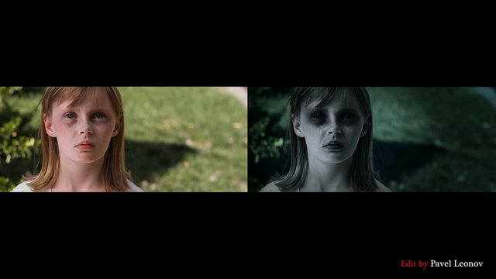
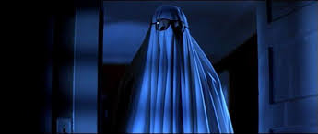

Sound –
Creating sound effects - https://www.youtube.com/watch?v=-LXBFmNRDwU
Instrument - https://www.youtube.com/watch?v=9d1yDCWicf0

Perspective –
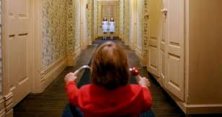
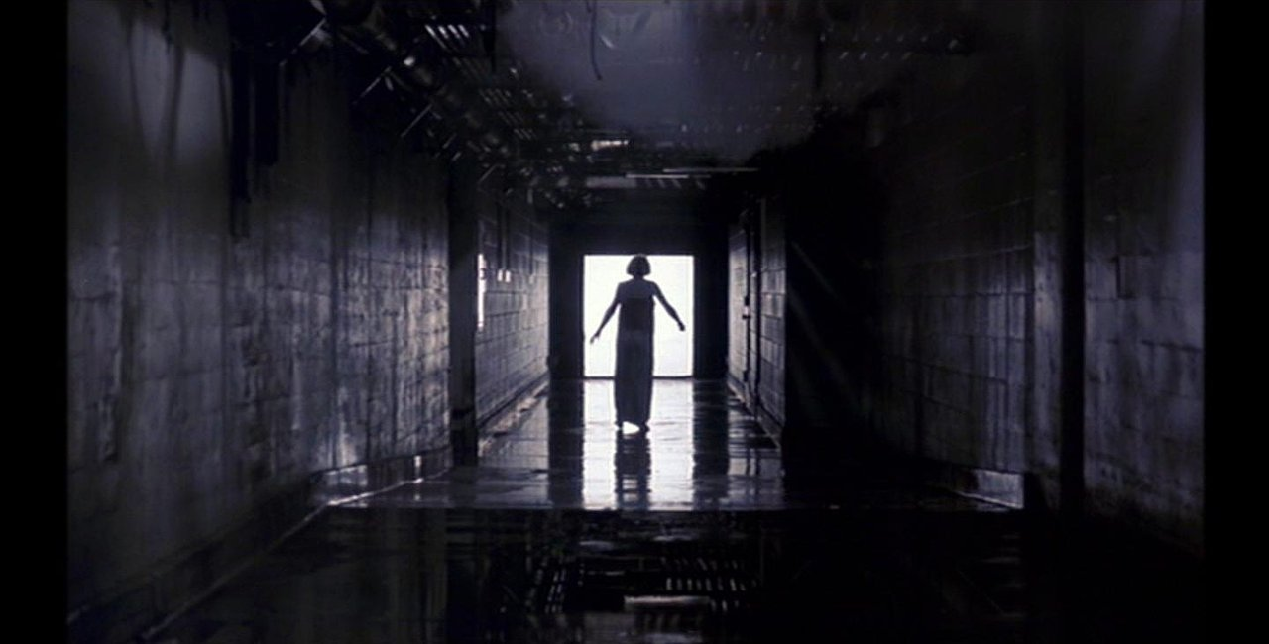

http://ourenglishclass.net/class-notes/writing/the-writing-process/craft/tone-and-mood/

4. Tropes & archetypes
http://screencrush.com/horror-movie-cliches/
http://tvtropes.org/pmwiki/pmwiki.php/Main/HorrorTropes

