FISHBOWL ACTIVITY
Name__________________________________
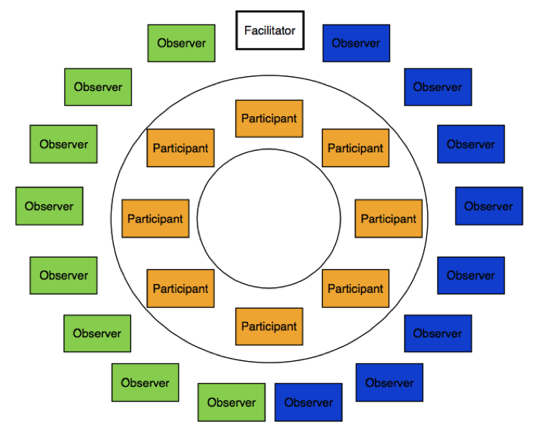
Fishbowl Articles & Discussion Instructions:
Topic: Is man’s basic nature inherently good or evil?
You will work with your partner within your pre-assigned groups in order to complete the following tasks (so in a group of four, two people will work together to address one side of the argument while the other two people will collaborate on the other side):
Articles (approximately 2-3 class periods):
- Closely read and annotate the texts on the nature of humanity and identify the central ideas for each. You should also identify within each article the pros and cons of each side of the argument. I would suggest using different colored highlighters or pencils to do this.
- Using evidence from the texts, develop a claim/counterclaim regarding whether man is inherently good or evil. Be sure that the claim and counterclaim are two sides of the same coin. This should be written as one sentence. Provide evidence and details from the texts in order to support your argument.

Sample topic: Implementation of a school dress code that requires students to wear uniforms.

Ex. “Although wearing school uniforms can arguably limit students’ ability to express themselves (COUNTERCLAIM), studies show that they are extremely cost effective and decrease bullying ; therefore, Plainedge High School should implement a school dress code (YOUR CLAIM).”
-OR-
Ex. “School uniforms may reduce the amount of money that students spend on clothes (COUNTERCLAIM), but because they limit kids’ abilities to express themselves freely and they have no positive impact on learning, they should not be mandated at Plainedge (YOUR CLAIM).”

Fishbowl (one or two class periods):
- On the day of the fishbowl discussion, you will meet with your partners for a few minutes to go over the main points and details that you will use to defend your argument. These must come directly from the text.
- You will separate into the inner and outer circles. Two of the four group members will be on the inside, and two will be on the outside. You will decide with your partner who will speak and who will observe. Bring your articles with you.
- Those on the INSIDE of the circle – you will discuss your ideas with each other one point at a time. Please try to limit yourself to only using information from the articles, not your own personal opinions (we’ll get to those later). You must speak at least twice in order to receive full credit. The person who is speaking will call on the next person who wants to speak, and there is no talking out of turn. Your PURPOSE is to defend your own argument while poking holes/pointing out flaws in the other side of the argument. If one person reads information from an article and you want to add onto it, defend it, or argue against it, you must use the texts. *This is not a random sharing of facts; it is the ability to defend your argument in a logical order. You must identify the title of the article, as well as the page/paragraph numbers you’re getting your info from so that everyone can follow along.
- Those on the OUTSIDE of the circle – write both you and your partners’ names and claim/counterclaim at the top of your notes page. Your job is to observe and take notes on any main points discussed in the fishbowl, as well as any questions that you have about the information you heard.

Evaluation:
Inside circle – you will be assessed on the amount you participate as well as the specific content/details you use from the articles in order to defend your argument.
Outside circle – you will be assessed on the quality and number of notes that you take during the discussion.

For the Speaker: Main Points
Fishbowl topic: ____________________________________________________________________________________________________________________________________
Point #1: Article title & page #__________________________________________

Evidence:

Point #2: Article title & page #__________________________________________

Evidence:

Point #3: Article title & page #__________________________________________

Evidence:

Point #4: Article title & page #__________________________________________

Evidence:

Notes for any special questions, connections, or alternative points of view that your classmates raised in the fishbowl:

For the Observer: Discussion Notes
Fishbowl topic: ____________________________________________________________________________________________________________________________________
Point #1:

Evidence:

Point #2:

Evidence:

Point #3:

Evidence:

Point #4:

Evidence:

Notes for any special questions, connections, or alternative points of view that your partner raised in the fishbowl:

Fishbowl Evaluation Form
Name:_______________________________
Role:________________________________

After the Discussion:
1. Formulate your own opinion based on today’s discussion:

2. What were your own personal strengths / the strengths of your partner throughout this process?

3. In what area(s) can you and your partner use some improvement?

4. Questions and/or topics for further investigation:

Fishbowl Articles

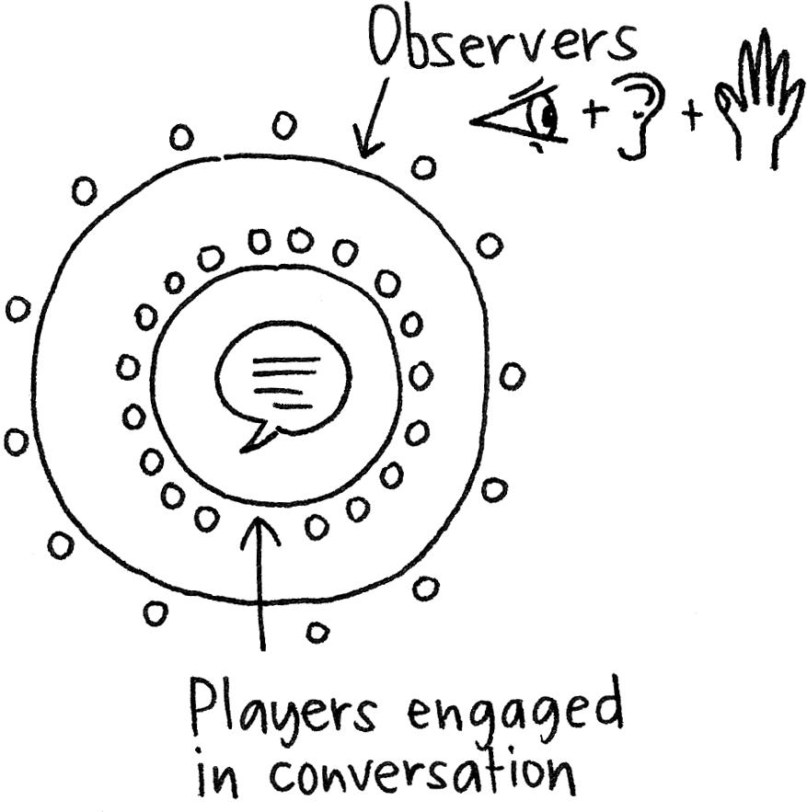

Topic: Human Nature:

Good or Evil?

Article #1: “The Social Influence of Good vs. Evil”
By Bryan Wood via huffingtonpost.com
When I ponder the concept of good versus evil, I pause for a moment to recognize that the words have varying meanings to different people. While one culture may view the stoning of women for sexual behavior perfectly acceptable, others will view it as being despicable and an abomination to humanity. The important fact is to isolate and define a form of evil that is all-encompassing for the human species and not varied between individual cultures.
As humans, we precariously straddle two worlds. One world is based on our genetic hard-wiring which is geared towards survival and aggression -- our animal instincts. Our other world is the modern, civilized society based on rules and conformity which we have created and enjoy. The vast majority of people reside prominently in civilized society, and they dismiss their instinct for aggression and dominance. Being a part of the group ensures safety and prosperity, and the group strongly influences and defines individual behavior.
This relationship between the group and the individual is a two-way street. The group defines rules and limitations, and the individual complies for the purpose of integration. The end result of this is mutually beneficial to the good of one and the good of many. Evil acts occur when one aspect of this system breaks down and either the motivations of the group as a whole become corrupted or an individual rebels against the norms created by society.
As a whole, we recognize evil acts as being those committed by individuals who have abandoned society. Deranged individuals who commit rampage style shootings, those who target children for sexual exploitation, those who target vulnerable women for rape, and so on. These are acts which, regardless of their root cause, have no seed of good within them. They are committed solely for the purpose of delivering pain, suffering, and torture to the victims, with no redeeming value to society, and without remorse.
When the individual breaks away from the group in this manner, there is very rarely any chance for true rehabilitation.
When the failure of good is on the side of the group as a whole, however, the result can be much different. If good people are subjected to degraded values within the group, even the best person can become subject to committing the worst acts. This is often highlighted in examples of heroes-turned-criminal in the military and police officers who find themselves on the wrong side of the law.
A war veteran is often revered as a hero in our society today, and most soldiers hold themselves to the highest standards of conduct while in battle. However, if the group as a whole becomes broken, the strength of the brotherhood between soldiers can drive many to do things which later carry grave regret. In January of 2012, such an example came to light in America.
A group of soldiers from the 3rd Battalion, 2nd Marines rose to infamy when a video surfaced on the internet depicting them urinating on dead Taliban fighters. The soldiers are heard saying "Golden like a shower," and "Have a great day buddy," while desecrating the remains. In our modern, civilized world, we would rank this act as evil under almost any terms, but it's important to remember this didn't take place here. It took place in the less civilized, less modern world of war, and it took place under conditions most would never dare to imagine much less experience. So, what went wrong?
Soldiers, while legally adults, are very often still within a very impressionable age. If I dare to think back to myself at the age of 19 or 20 years old, I hardly recall a mature adult. If people at such an age are removed from an environment of order, structure and safety, and placed in an environment of disorder, chaos, and fear, the motivation of the group shifts, and the results can devastate lives.
In a scenario such as the soldiers of the 3rd Battalion, 2nd Marines, the motivating factor for the group became anger and rage. As the soldiers dealt with significant combat resulting in heavy casualties, the individuals responded in suit. While urinating on the remains of others may be regarded as evil, it is very important for others to form the distinction between the act itself and the people committing it. The act may be evil, but the people themselves are not. The moral compass of the group lost its way, and the natural drive for the individuals to conform brought them to a very unwanted infamy.
Violence and evil are no strangers to our world, and they are never going away. However, if we learn to recognize the sources of derelict behavior, we may be able to intervene and prevent good people from making tragic decisions.

Article #2: “Babies know the difference between good and evil at six months, study reveals”
By DAVID DERBYSHIRE via dailymail.co.uk
At the age of six months babies can barely sit up - let along take their first tottering steps, crawl or talk.
But, according to psychologists, they have already developed a sense of moral code - and can tell the difference between good and evil.
An astonishing series of experiments is challenging the views of many psychologists and social scientists that human beings are born as 'blank slates' - and that our morality is shaped by our parents and experiences.
Instead, they suggest that the difference between good and bad may be hardwired into the brain at birth.
In one experiment involving puppets, babies aged six months old showed a strong preference to 'good' helpful characters - and rejected unhelpful, 'naughty' ones.
In another, they even acted as judge and jury. When asked to take away treats from a 'naughty' puppet, some babies went further - and dished out their own punishment with a smack on its head.
Professor Paul Bloom, a psychologist at Yale University in Connecticut, whose department has studied morality in babies for years, said: 'A growing body of evidence suggests that humans do have a rudimentary moral sense from the very start of life.
'With the help of well designed experiments, you can see glimmers of moral thought, moral judgment and moral feeling even in the first year of life.
'Some sense of good and evil seems to be bred in the bones.'
For one study, the Yale researchers got babies aged between six months and a year to watch a puppet show in which a simple, colourful wooden shape with eyes tries to climb a hill.
Sometimes the shape is helped up the hill by a second toy, while other times a third character pushes it down.
After watching the show several times, the babies were shown the helpful and unhelpful toys. They showed a clear preference for the helpful toys - spending far longer looking at the 'good' shapes than the 'bad' ones.
'In the end, we found that six- and ten-month-old infants overwhelmingly preferred the helpful individual to the hindering individual,' Prof Bloom told the New York Times.
'This wasn't a subtle statistical trend; just about all the babies reached for the good guy.'
Two more tests found the same moral sense.
In one, the researchers devised a 'one-act morality play', in which a toy dog tries to open a box. The dog is joined by a teddy bear who helps him lift the lid, and a teddy who stubbornly sits on the box.
They also made the babies watch a puppet cat play ball with two toy rabbits. When the cat rolled the ball to one rabbit, it rolled the ball straight back. But when the cat rolled it to the second rabbit, it picked up the ball and ran off.
'In both studies, five-month-old babies preferred the good guy - the one who helped to open the box; the one who rolled the ball back - to the bad guy,' said Professor Bloom.
When the same tests were repeated with 21-month-old babies, they were given a chance to dish out treats to the toys - or take treats away.
Most toddlers punished the 'naughty rabbit' by taking away treats. One even gave the miscreant a smack on the head as a punishment.
Although the studies appear to show that morality is hard-wired into babies brains, some psychologists urged caution.
Dr Nadja Reissland, of Durham University, said babies started to learn the difference between good and bad from birth.
'Everything hinges on who decides what is normal,' she said. 'By saying pushing the ball up the hill is helpful, the researchers are making a moral judgement. The babies might just prefer to see things go up rather than down.
'In the other test, perhaps the bear closes the box to prevent the dog from getting in there because there is something dangerous inside. It is like a mother keeping children out of an area where there is something harmful.'

Article #3: “Good vs. Evil, Boston and Beyond”
By Sam Sacks (a political commentator and journalist, the last five years spent covering politics in Washington, DC.)
I don’t personally believe in a dark-force permeating around the universe known as “evil.”
But, I know that when a shrapnel bomb mows down an eight-year-old while he’s standing on the street waiting to hug his dad after the Boston Marathon, then some sort of “evil” is present.
Call it whatever you want, something stalks the planet today. It uses unspeakable violence and a brutal indifference to steal lives, to steal innocence from our kids, and to steal hope from our idealists.
What causes it has been written about for much longer than I’ve been writing for, and much, much longer before that.
But, we do know that every time this “evil” flares up in shocking real-life colors, it’s met with an equally powerful force that’s best described as “good.”
We learn so much about ourselves during these times of horror. We learn that we run toward the violence, and toward the screams and the blood. We learn that we shut away our most Ayn Randian desires and shower love upon those who are crippled. And we do all of these things with little thought about our own safety. We sacrifice ourselves.
Yesterday, splashed all across social media was that Fred Rogers quote, “Look for the helpers. You will always find people helping.”
It’s an interesting critique on humanity. Why is the best of us brought out during the worst of times? It, too, is a question that’s been pondered for millennia.
Underpinning religious, political, and philosophic doctrine is a question about human nature. Is it inherently evil? Or good? Or is there such a thing at all?
Clearly, there is something in our nature that flicks on a guiding light when the world turns black. And if we are to judge human nature, it should be during these times, when we act not based on what some cable news outlet says, or what some fearful politician says, but instead what our own guts tell us to do, when people are dying around us and it’s up to us to save them.
Like first responders in New York City who rushed toward the towering infernos. Like teachers at Newtown who rushed toward the gunfire. And like Bostonians who rushed toward the white smoke, the broken glass and the bloody sidewalks on Monday. This is our nature.
This isn’t exclusively American. In places like Iraq and Afghanistan, these bombings are near regular occurrences, and often include the far deadlier second blasts aimed at first responders. Yet, as soon as the first blast recedes and the shrapnel settles, the heroes continue rushing in with little regard for their own safety.
This is also true of those responding to the victims of our drone strikes abroad. Those attacks, too, are often followed up by a “double-tap” – or, second strike, but the helpers still run in.
Again, this is our nature, which is so rarely on display day-to-day.
It’s disturbing how many of us wander around the world listlessly, disregarding our fellow citizens who are in need, too busy to focus on little else besides our own condition. Recently, politicians promoting austerity have promoted this kind of vicious disregard toward the helpless.
But, when tragedy strikes that apathy disappears with the blood from our ghost white faces. Out of instinct, we become helpers, and that same person we may have disregarded on the street corner the day before, or actually cursed out while behind the wheel a week ago, or called a “taker” during the elections, now becomes the object of all our compassion. We sacrifice life and limb to help a stranger.
This proxy battle – when evil strikes, and then good consumes it – occurred once again on Monday. And once again, good won the day. It always does. It must.
But what will win tomorrow? And the next day? And the day after that?
Far too often, out of tragedies like this, evil creeps back in to win the war.
In the coming days and weeks, many of our questions will be answered and we’ll learn who was responsible for this and why they did it. But, can we trust ourselves to react appropriately to these answers? Upon learning who did this, can we trust ourselves to rely on that “good” that got us through Monday, to get us through the rest of the week, month, year?
I ask this question after more than a decade of two wars, and inside a drastically different United States now under surveillance, yet still unable to stop attacks like this. I asked this question one day after the terrifying story of hunger strikes and brutality in Guantanamo Bay was reported.
Just like on Monday, “good” won the day on 9/11. The world was amazed by the heroism of average Americans reacting to the events of that day. But there’s been little in the way of good in the world since.
Good won the day after Newtown, but since then guns have been flying off the shelves and on to the streets, and thousands have been murdered in just the few months after. Where did all that good go?
CNN’s major takeaway from President Obama’s statements on the bombings was that he didn’t use the word “terrorism.” It’s as though whenever tragedy strikes, we must pay penance with the war on terror gods.
We take a cruel comfort in knowing it was terrorism. It already fits neatly into our fearful worldview. We know the enemy and we know how to fight them. We’ve been doing it for twelve years.
But in those twelve years, we’ve allowed evil to flourish around the globe. It’s embodied in the suicide bombings and car bombings that mar daily life in war-torn regions of the Middle East. It’s embodied in the relentless drone bombing campaigns that kill similar eight-year-olds in Pakistan. And it’s embodied in the right-wing xenophobia and racism that’s flared up in the United States in reaction to a decade of war, a growing security state apparatus, and economic strife.
Every single time, when the smoke clears, when our instincts subside, and when our perspective is lost, the retrograde purveyors of fear rush on to our TV and computer screens. Some motivated by religious zeal, others by political extremism, and other by profits, they play to our darkest emotions.
We must resist the fear, the despair, and most importantly, the vengeance that they promote. These are all instruments of the same evil we saw at the finish line in Boston. And they are at the root of why we’ve let evil seize the last decade, and why, unless we change course as a people here in the United States and abroad, evil will seize the next decade, too.
There is uncertainty and danger ahead. It’s become the way of the world in recent decades. But it can’t be any more uncertain and dangerous than what hundreds of American rushed toward on Monday in Boston. And they rushed toward it, not with rifles, drones, and suspicion, but instead with hands free, ready to help.
That’s the bravery and compassion that we need moving forward. And it’s the only posture that will give us a chance to restrain the evil beyond Boston.

Article #4: “Is Human Nature Good or Evil?”
BY ANTHONY CHIORAZZI
SEPTEMBER 17, 2012
Anthony Chiorazzi researches cultures and has published articles on such diverse American religious communities as the Shakers, Quakers, Amish, Hare Krishnas, Zoroastrians, Mormons, Gullah, Navajo and many more. He is currently a graduate student at Oxford University.
A Christian considers this age-old question by interviewing Holocaust survivors—and turning the mirror on himself.
Gabriella Karin, an 82-year-old Holocaust survivor, sits opposite me at a trendy Italian restaurant across the street from the Los Angeles Museum of the Holocaust. “Human nature is basically good,” she says, digging into a Caesar salad.
I ask the question again. She doesn’t bristle. It’s a question that I’d wanted to ask a Holocaust survivor my whole life: What is the true nature of humankind? Are we inherently good or evil?
As a Christian, I’ve always believed humankind is primarily corrupt. We turned from God, sinned and now need a Savior to bridge our separation from Him.
In fact, in Matthew 7:11, Christ even says that we’re evil.
But I wanted to hear it from those who’ve probably thought about that question more than anyone else.
What do you mean? I thought to myself. You’re a Holocaust survivor. Most of your family perished in Nazi Europe. Of course man is evil.
WHAT IF THERE WERE A DECREE IN AMERICA THAT FOR 24 HOURS, YOU COULD DO ANYTHING YOU WANTED—MURDER, ROBBERY, RAPE—AND NOT HAVE ANY CONSEQUENCES?
Karin continues: “Circumstances sometimes make people do bad things.” She explains that Hitler was an agitator who helped ferment a latent anti-Semitism in Germany. “But God didn’t do it [the Holocaust]. People did it.” Karin’s melodious Slovakian accent gives no hint of a woman who has experienced one of humankind’s worst genocides.
It takes a moment for her words to sink in. They echo my Christian belief in free will: Our choice to do bad or good. She also tells me about Karol Blanar, the Christian man who saved her life and eight others—including her mother and father—by hiding them for nine months in a floor of his apartment, across the street from the Gestapo headquarters. “I owe him so much for giving me a chance to live,” she says.
As the sun dapples our faces on the patio of La Piazza Ristorante Italiano, I think that maybe man is not as bad as I thought. After all, Karin says that many people during the Holocaust chose to risk their lives to save Jews. How do these good deeds factor in?
The next day, I sit with Peter Daniels, who has lived through 76 years and a genocide, in a little café at the top of the Museum of Tolerance in Los Angeles. Daniels tells me to imagine: What if there were a decree in America that for 24 hours, you could do anything you wanted—murder, robbery, rape—and not have any consequences? “What do you think the increase of crime would be for that twenty-four hours?” he asks.
Here’s someone who has pondered human nature, I thought. “What would you do during those 24 hours?” I ask.
“I would lock myself in my room and not let anyone in for those 24 hours,” he says.
Daniels knows evil.At four years old, he was kicked out of school for being a Jew. He remembers the yellow star pinned on his shirt and jacket.
From 1943 to 1945, Daniels and his single mother were at Terezin, a Czechoslovakian concentration camp.Of the 15,000 children who passed through Terezin, only 100 survived—and Daniels was one.
I ask Daniels why humans have an inclination for evil.
“IF I WERE ON THE OTHER SIDE ... WOULD I RISK MY LIFE AND ENDANGER MY FAMILY AND COME TO MY OWN RESCUE? I DON’T KNOW. IT’S A TERRIBLE THING TO LIVE WITH.”
“Misguided idealism,” he says. Daniels explains that the Nazis believed they were doing the higher good, by getting rid of the “subhumans”—including Jews, Gypsies and homosexuals—that didn’t measure up to their Aryan ideals. Daniels says the Nazis were masters of propaganda.
As I stroll through the halls of the Museum of Tolerance and pass exhibit after exhibit documenting human cruelty, I think about “misguided idealism.” I think of all the injustices that have been committed in the name of my faith, like the Crusades, the Thirty Years War and the Salem Witch Trials. These wars and acts of violence might have seemed like a good idea for many “believers” at the time, though they were deeply and destructively misguided.
With my righteous belief that man is evil, I begin to wonder if I’m misguided—like the accusers in Salem—projecting onto others what I fear is in me.
It’s night. I’m tired. I have more interviews tomorrow, but I check out the Los Angeles Museum of the Holocaust website. A sidebar question on their site catches my attention. It asks: “If you were told to join the German army or risk imprisonment and endanger your family, would you: A.) Refuse to join and risk imprisonment in a concentration camp. B.) Flee or go into hiding. C.) Join the army. D.) Don’t know.”
I don’t like the question. I turn off my laptop and go to sleep.
“I wouldn’t be here if it weren’t for good people,” Betty Hyatt, 77, tells me in the library of the Los Angeles Museum of the Holocaust.
Born in Belgium, Hyatt escaped from the Nazis in the early 1940s with her mother, grandmother and brother and fled into the forests of southern France. For years they survived in the woods, often battling rats for chestnuts.
During Nazi raids of the area, Hyatt says she hid behind trees, close enough to hear the crunch of Gestapo footsteps in the snow, and fearing that the white of her misting breath might betray her.
Of human nature, Betty says some people are good and some people are bad—and you never know who will do the good. Betty says when she visited the region of France where she hid during the Holocaust that the people who risked their lives to help save her family were simple farmers, still working the land, who just chose to do good.
Choice? There was that concept again, I say to myself.Maybe humans weren’t bad or good, I think. Maybe humans had a choice? But what did humans choose?
But then Betty shocks me. She says something that I never thought a Holocaust survivor would ever say.
“I often sit and wonder, if I were on the other side, if I were a French Christian, would I risk my life and endanger my family and come to my own rescue?” she asks. “I don’t know. It’s a terrible thing to live with.”
I’m surprised, but impressed with her honesty. I’m reminded of Romans 3:23, “For all have sinned and come short of the glory of God.” I wonder what I would do if I had to face such moral dilemmas. How would I choose? I hope I would not fall “short of the glory of God.”
That night, I visit the Los Angeles Museum of the Holocaust website again. I stare at the question: If you were told to join the German army or risk imprisonment and endanger your family, would you …
I click my answer, and check the results.
The majority responded that they would flee, that they were unsure what they would do, or that they would go into hiding or join the German army. Only a courageous minority said they would “Refuse to join and risk imprisonment in a concentration camp.”
I wasn’t one of them.

