FISHBOWL ACTIVITY
Name__________________________________
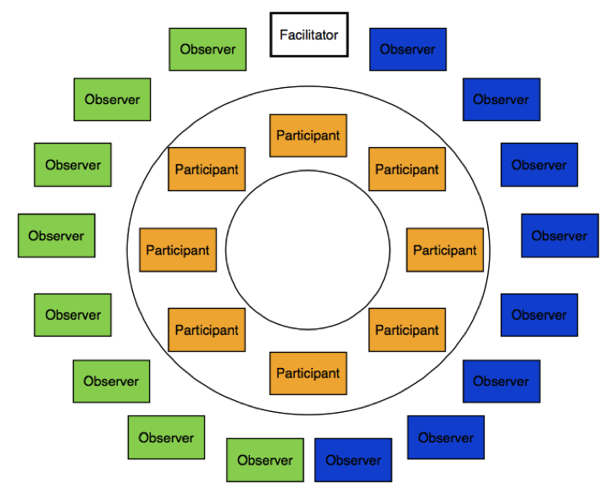
Fishbowl Articles & Discussion Instructions:
Assignment: According to Joseph Campbell, one of life’s great moral questions is: “Will we live for the machine, or will we live for humanity?”
Essential question: Should humans be replaced by machines in the workplace?
You will work with your partner within your pre-assigned groups in order to complete the following tasks (so in a group of four, two people will work together to address one side of the argument while the other two people will collaborate on the other side):
Articles (approximately 2-3 class periods):
- Closely read and annotate the texts on the nature of humanity and identify the central ideas for each. You should also identify within each article the pros and cons of each side of the argument. I would suggest using different colored highlighters or pencils to do this.
- Using evidence from the texts, develop a claim/counterclaim regarding whether humans should be replaced by technology in the workplace. Be sure that the claim and counterclaim are two sides of the same coin. This should be written as one sentence. Provide evidence and details from the texts in order to support your argument.

Sample topic: Implementation of a school dress code that requires students to wear uniforms.

Ex. “Although wearing school uniforms can arguably limit students’ ability to express themselves (COUNTERCLAIM), studies show that they are extremely cost effective and decrease bullying ; therefore, Plainedge High School should implement a school dress code (YOUR CLAIM).”
-OR-
Ex. “School uniforms may reduce the amount of money that students spend on clothes (COUNTERCLAIM), but because they limit kids’ abilities to express themselves freely and they have no positive impact on learning, they should not be mandated at Plainedge (YOUR CLAIM).”

Fishbowl (one or two class periods):

- On the day of the fishbowl discussion, you will meet with your partners for a few minutes to go over the main points and details that you will use to defend your argument. These must come directly from the text.
- You will separate into the inner and outer circles. Two of the four group members will be on the inside, and two will be on the outside. You will decide with your partner who will speak and who will observe. Bring your articles with you.
- Those on the INSIDE of the circle – you will discuss your ideas with each other one point at a time. Please try to limit yourself to only using information from the articles, not your own personal opinions (we’ll get to those later). You must speak at least twice in order to receive full credit. The person who is speaking will call on the next person who wants to speak, and there is no talking out of turn. Your PURPOSE is to defend your own argument while poking holes/pointing out flaws in the other side of the argument. If one person reads information from an article and you want to add onto it, defend it, or argue against it, you must use the texts. *This is not a random sharing of facts; it is the ability to defend your argument in a logical order. You must identify the title of the article, as well as the page/paragraph numbers you’re getting your info from so that everyone can follow along.
- Those on the OUTSIDE of the circle – write both you and your partners’ names and claim/counterclaim at the top of your notes page. Your job is to observe and take notes on any main points discussed in the fishbowl, as well as any questions that you have about the information you heard.

Evaluation:
Inside circle – you will be assessed on the amount you participate as well as the specific content/details you use from the articles in order to defend your argument.
Outside circle – you will be assessed on the quality and number of notes that you take during the discussion.

For the Speaker: Main Points
Fishbowl thesis: ____________________________________________________________________________________________________________________________________
Point #1: Article title & page #__________________________________________

Evidence:

Point #2: Article title & page #__________________________________________

Evidence:

Point #3: Article title & page #__________________________________________

Evidence:

Point #4: Article title & page #__________________________________________

Evidence:

Point #5: Article title & page #__________________________________________

Evidence:

For the Observer: Discussion Notes
Fishbowl thesis: ____________________________________________________________________________________________________________________________________
Point #1:

Evidence:

Point #2:

Evidence:

Point #3:

Evidence:

Point #4:

Evidence:

Point #5:

Evidence:

Fishbowl Evaluation Form
Name:_______________________________
Role:________________________________

After the Discussion:
1. Formulate your own opinion based on today’s discussion:

2. What were your own personal strengths / the strengths of your partner throughout this process?

3. In what area(s) can you and your partner use some improvement?

4. Questions and/or topics for further investigation:

Fishbowl Articles

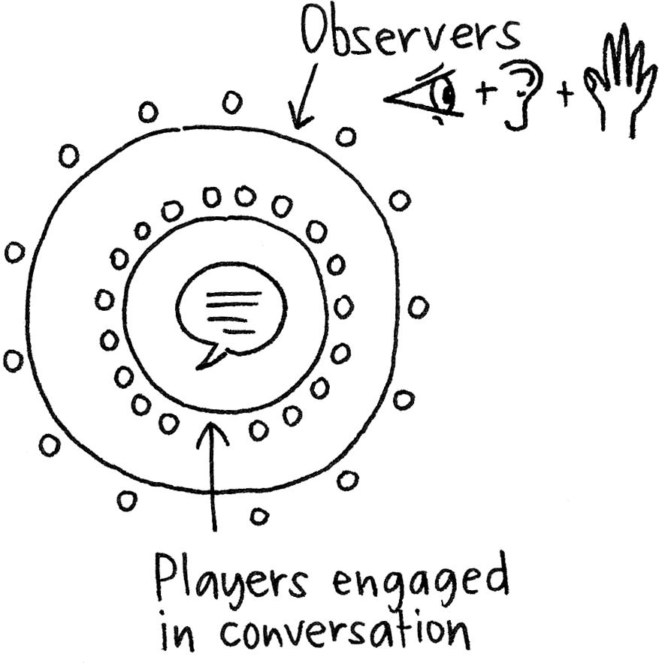

Topic: Man v. Machine

Text #1: “It's a Man vs. Machine Recovery”
By David J. Lynch January 05, 2012

Via Businessweek.com
The U.S. produces almost one-quarter more goods and services today than it did in 1999, while using almost precisely the same number of workers. It’s as if $2.5 trillion worth of stuff—the equivalent of the entire U.S. economy circa 1958—materialized out of thin air.
Although businesses haven’t added many people, they’ve certainly bulked up on machines. Spending on equipment and software hit an all-time high in the third quarter of 2011. “Huge advances in technology have allowed businesses to do more with less,” vaporizing jobs for everyone from steelworkers to travel agents, President Barack Obama warned in December.
So are robots getting all the good jobs? This year may provide the answer as the economy gathers steam. Most economists, cheered by 540,000 hires since Labor Day, say technology inevitably destroys some jobs even as it ultimately creates new ones. But with more than 20 million Americans still jobless or underemployed, others worry that something fundamental has changed. “What’s different now is the speed and scale of what’s happening,” says Erik Brynjolfsson, director of the MIT Center for Digital Business. Brynjolfsson and Andrew McAfee, co-authors of the recently published book Race Against the Machine, argue that the economy is in the early stages of a “Great Restructuring” that is hollowing out the labor market and exacerbating inequality.

Nonsense, say economists including James D. Hamilton of the University of California at San Diego. There’s nothing new about machines replacing people. In 1900, 41 percent of Americans worked on farms. Today, thanks to labor-saving tractors and combines, the figure is less than 2 percent. Yet ex-farm workers found new jobs. And as manufacturing grew leaner in recent decades, factory workers—or their children—migrated to finance, health care, computers, and other growing industries.
“In 2005 the average U.S. worker could produce what would have required two people to do in 1970, what would have required four people in 1940, and would have required six people in 1910,” Hamilton writes in an e-mail. “The result of this technological progress was not higher unemployment but instead rising real wages. The evidence from the last two centuries is unambiguous—productivity gains lead to more wealth, not poverty.”
Americans have fretted about a dystopian future since the first industrial robot (called “Unimate”) started work at a General Motors (GM) plant in Ewing Township, N.J., in 1961. The worries grew more acute last year as the jobs-poor recovery ground on. Chris Matthews, host of MSNBC’s Hardball, recently ruminated on air about ubiquitous automated kiosks as well as the replacement of “seven or eight cameramen” on his program with machines. “Everywhere we go, it’s robots,” he said.

Google (GOOG) last year unveiled driverless cars. Lionbridge Technologies (LIOX) is taking orders for an automated translation service. Medical device maker Boston Scientific (BSX) is automating its Quincy (Mass.) distribution center, the company’s largest, with robots made by Kiva Systems of North Reading, Mass.
Technology is not just revolutionizing the assembly line. Paralegals can’t match software in accurately searching thousands of documents for specific words or patterns. New software apps easily best journeyman sportswriters at penning routine game wrap-ups. “The era we’re in is one in which the scope of tasks that can be automated is increasing rapidly, and in areas where we used to think those were our best skills, things that require thinking,” says David Autor, a labor economist at Massachusetts Institute of Technology.
As digital technology spreads, the classic relationship between rising output and rising employment—known as Okun’s Law—now appears to be broken. If the law, which postulates that every 3 percent gain in output should reduce the jobless rate by a percentage point, still applied, then today’s nearly 9 percent rate would be about 1 percent.
Crowded unemployment lines, however, aren’t necessarily a sign that machines are winning a zero-sum fight with humans. The surge of spending on automation and IT systems, for example, is one of the economy’s strongest props. In the third quarter, nonresidential investment, which includes labor-saving machinery, contributed 1.41 percentage points to gross domestic product growth, second only to consumer spending. Lincoln Electric Holdings (LECO), a maker of robotic welding gear, reported $55.5 million in third-quarter profits, up 71 percent from the same period in 2010.
Businesses are spending more on technology now because they spent so little during the recession. Yet total capital expenditures are still barely running ahead of replacement costs. “Most of the investment we’re seeing is simply replacing worn-out stuff,” says economist Paul Ashworth of Capital Economics.
So if machines aren’t responsible for the dearth of jobs, what is? Simple: lack of demand. Industry is using less of its productive capacity today than it did at the low point of the 1990-91 recession, according to the Federal Reserve. “We need a new source of demand,” says MIT’s Autor. “If people aren’t buying stuff, then no one’s hiring workers.”
The prosperous 1990s revealed the power of demand to simultaneously boost employment and spending on machines. Companies binged on new equipment and software in the late 1990s even more than today, yet the unemployment rate averaged 4.4 percent, notes economist Dean Baker of the Center for Economic & Policy Research in Washington, D.C. From the first quarter of 1997 through the end of 2000, even as productivity increased 14 percent, demand for goods and services was so great that the private sector created more than 9 million jobs.
One thing that’s different now: Instead of lifting all boats, as it once did, technology is sorting workers into winners and losers. Over the past three decades job growth has been fastest among high- and low-skill jobs, while mid-skill occupations atrophied, according to economists Jaison Abel and Richard Deitz of the Federal Reserve Bank of New York. Although the economy created nearly 50 million new nonfarm positions in that period, technology cut the ranks of some workforce mainstays, such as machine operators, by more than half.
Flat-lining living standards and a rich-man, poor-man job market add up to a scary new era. Despite their concerns, Brynjolfsson and McAfee remain “digital optimists.” Eventually, they say, revolutionary technologies will spawn unimagined new businesses and jobs. There’s certainly room for them. By the Congressional Budget Office’s reckoning, total output in the third quarter was 5 percent below potential. That amounts to almost $800 billion of missing demand—enough to occupy both man and machine.

Text #2: Human Takeover by Machines May be Closer than We Think”
By Tia Ghose
Via NBCNews.com/Science
Are you prepared to meet your robot overlords?
The idea of super-intelligent machines may sound like the plot of "The Terminator" or "The Matrix," but many experts say the idea isn't far-fetched. Some even think the singularity — the point at which artificial intelligence can match, and then overtake, human smarts — might happen in just 16 years.
But nearly every computer scientist will have a different prediction for when and how the singularity will happen.
Some believe in a Utopian future, in which humans can transcend their physical limitations with the aid of machines. But others think humans will eventually relinquish most of their abilities and gradually become absorbed into artificial intelligence (AI)-based organisms, much like the energy-making machinery in our own cells.
In his book "The Singularity is Near: When Humans Transcend Biology" (Viking, 2005), futurist Ray Kurzweil predicted that computers will be as smart as humans by 2029, and that by 2045, "computers will be billions of times more powerful than unaided human intelligence," Kurzweil wrote in an email to LiveScience.
"My estimates have not changed, but the consensus view of AI scientists has been changing to be much closer to my view," Kurzweil wrote.
Bill Hibbard, a computer scientist at the University of Wisconsin-Madison, doesn't make quite as bold a prediction, but he's nevertheless confident AI will have human-level intelligence sometime in the 21st century.
"Even if my most pessimistic guess is true, it means it's going to happen during the lifetime of people who are already born," Hibbard said.
But other AI researchers are skeptical.
"I don't see any sign that we're close to a singularity," said Ernest Davis, a computer scientist at New York University.
While AI can trounce the best chess or Jeopardy player and do other specialized tasks, it's still light-years behind the average 7-year-old in terms of common sense, vision, language and intuition about how the physical world works, Davis said.
For instance, because of that physical intuition, humans can watch a person overturn a cup of coffee and just know that the end result will be a puddle on the floor. A computer program, on the other hand, would have to do a laborious simulation and know the exact size of the cup, the height of the cup from the surface and various other parameters to understand the outcome, Davis said.
Once the singularity occurs, people won't necessarily die (they can simply upgrade with cybernetic parts), and they could do just about anything they wanted to — provided it were physically possible and didn't require too much energy, Hibbard said.
The past two singularities — the Agricultural and Industrial revolutions — led to a doubling in economic productivity every 1,000 and 15 years, respectively, said Robin Hanson, an economist at George Mason University in Washington, D.C., who is writing a book about the future singularity. But once machines become as smart as man, the economy will double every week or month.
This rapid pace of productivity would be possible because the main "actors" in the economy, namely people, could simply be replicated for whatever it costs to copy an intelligent-machine software into another computer.
That productivity spike may not be a good thing. For one, robots could probably survive apocalyptic scenarios that would wipe out humans.
"A society or economy made primarily of robots will not fear destroying nature in the same way that we should fear destroying nature," Hanson said.
And others worry that we're barreling toward a future that doesn't take people into account. For instance, self-driving cars could improve safety, but also put millions of truck drivers out of work, Hibbard said. So far, no one is planning for those possibilities.
"There are such strong financial incentives in using technology in ways that aren't necessarily in everyone's interest," Hibbard said. "That's going to be a very difficult problem, possibly an unsolvable problem."
Some scientists think we are already in the midst of the singularity.
Humans have already relinquished many intelligent tasks, such as the ability to write, navigate, memorize facts or do calculations, Joan Slonczewski, a microbiologist at Kenyon College and the author of a science-fiction book called "The Highest Frontier," (Tor Books, 2011). Since Gutenberg invented the printing press, humans have continuously redefined intelligence and transferred those tasks to machines. Now, even tasks considered at the core of humanity, such as caring for the elderly or the sick, are being outsourced to empathetic robots, she said.
"The question is, could we evolve ourselves out of existence, being gradually replaced by the machines?" Slonczewski said. "I think that's an open question."
In fact, the future of humanity may be similar to that of mitochondria, the energy powerhouses of cells. Mitochondria were once independent organisms, but at some point, an ancestral cell engulfed those primitive bacteria, and over evolutionary history, mitochondria let cells gradually take over all the functions they used to perform, until they only produced energy.
"We're becoming like the mitochondria. We provide the energy — we turn on the machines," Slonczewski told LiveScience. "But increasingly, they do everything else."

Text #3: “Humans vs. Machines: Match Made in Heaven, or Oil and Water?”
BY SCOTT JONES

Via Wired.com
Are bots taking over the world? Can machines totally replace humans, especially in the information space? Or is there a need for just the right combination of human and artificial intelligence — Hybrid Intelligence?
The debate over humans versus machines has been a topic of discussion for a while now, from the creation in the 1950s of the Turing test to “2001: A Space Odyssey’s HAL and the machine takeover of iRobot.
It’s been argued that by the end of the century highly effective robots will replace most kinds of physical laborers, service workers, and even truck drivers. Those robots won’t require food or sleep to operate. In these cases, humans would only be back-end designers and strategists because their inclusion in the hands-on process of work would decrease productivity.
Now Google Glass can give you directions and tell you how long the Brooklyn Bridge is. Even without your asking, Google Glass can tell you if your flight is on time.
But in the real-time information space, there’s a limit to how well bots can zero in on answers to some questions. That’s where human intelligence can help, complemented by the speed, accessibility and accuracy that technology can provide. The robust answers users demand rely upon a perfect mix of human and artificial intelligence: let’s call it “Hybrid Intelligence.” And the way it develops will determine the future of how we consume content.
The explosive growth of mobile devices, the continued propagation of voice recognition software, and web users’ expectation of search results that truly get what they’re searching for all underline one core fact of technology today: users demand the information they need at all times of the day or night, and they want those answers to be immediate, relevant, accurate and easy to understand. The market is still trying to figure out the best way to deliver that kind of information and who should deliver it – humans or machines (i.e. technology).
Although algorithmic approaches have made progress in recent years, this science has yet to be perfected. One example is Narrative Science, which leverages data available to a brand and applies artificial intelligence algorithms to extract key information and build a story. This approach has been used by well-known brands to create additional content for consumers as well as business insights. We’ve also seen attempts to tie content to ROI by algorithmically identifying topics with high advertising potential based on search engine queries. In the case of voice recognition software, Siri has made waves by responding to users’ questions with machine-generated knowledge.
On the other end of the spectrum is predominantly human-driven content creation. While this can be offered via platforms like Yelp or Foursquare that encourage interactivity, sharing and personalization, it’s not typically backed by the kind of infrastructure that enables quick, relevant answers, whether through mobile, text message or voice software. These interactive sites and even more traditional media sites support their content by using SEO tactics and other algorithmic approaches.
So how does Hybrid Intelligence work? Because the algorithms of search enable immediate results, platforms can use algorithms to their advantage, optimizing SEO in order to drive content higher in search results. From there, users can access not just lists of addresses, available products or services, and prices, but user-generated or expert-written content that offers the personalization they want and acknowledges nuances in their original queries. It’s something social media sites like Facebook and Twitter are good at. With those platforms, human beings create much of the content, but many also rely on bots to continually provide users with timely information. Bots free up the humans’ hands, while humans keep the bots accurate when “timely” information suddenly needs updating.
Hybrid Intelligence is especially relevant in mobile. We have a tremendous appetite for information on the fly, as recent studies on mobile usage have shown. More than half of all smartphone users turn to location-based services for information or recommendations. Four out of five smartphone users check their devices to find information about retail purchases. In these cases, the technology provides a portal to such things as reviews, recommendations and insight delivered by human beings whose perspectives they trust.
In the question-and-answer space, understanding users’ preferences for “content snacking” is critical. The key is providing a combination of searchable results and brief, yet personal human-generated responses combined with a sophisticated mobile strategy that meets users’ demands for information wherever they may be. When handled correctly, Hybrid Intelligence is accurate, quick, easily understood, sensible, and recognizable as authentic.
As users’ demands increase for detailed, relevant and accurate information wherever they may be, and whenever they may need it, Hybrid Intelligence will continue to evolve.

Text #4: “Humans 1, Robots 0”

Cashiers Trump Self-Checkout Machines at the Grocery Store
Via online.wallstreetjournal.com
Computers seem to be replacing humans across many industries, and we're all getting very nervous.
But if you want some reason for optimism, visit your local supermarket. See that self-checkout machine? It doesn't hold a candle to the humans—and its deficiencies neatly illustrate the limits of computers' abilities to mimic human skills.
The human supermarket checker is superior to the self-checkout machine in almost every way. The human is faster. The human has a more pleasing, less buggy interface. The human doesn't expect me to remember or look up codes for produce, she bags my groceries, and unlike the machine, she isn't on hair-trigger alert for any sign that I might be trying to steal toilet paper. Best of all, the human does all the work while I'm allowed to stand there and stupidly stare at my phone, which is my natural state of being.
There is only one problem with human checkers: They're in short supply. At my neighborhood big-box suburban supermarket, the lines for human checkers are often three or four deep, while the self-checkout queue is usually sparse. Customers who are new to self-checkout might take their short lines to mean that the machines are more efficient than the humans, but that would be a gross misunderstanding.
As far as I can tell, the self-checkout lines are short only because the machines aren't very good.
They work well enough in a pinch—when you want to check out just a handful of items, when you don't have much produce, when you aren't loaded down with coupons. But for any standard order, they're a big pain. Perversely, then, self-checkout machines' shortcomings are their best feature: because they're useless for most orders, their lines are shorter, making the machines seem faster than humans.
In most instances where I'm presented with a machine instead of a human, I rejoice. I prefer an ATM to a flesh-and-blood banker, and I find airport check-in machines more efficient than the unsmiling guy at the desk. But both these tasks—along with more routine computerized skills like robotic assembly lines—share a common feature: They're very narrow, specific, repeatable problems, ones that require little physical labor and not much cognitive flexibility.
Supermarket checkout—a low-wage job that doesn't require much training—sounds like it should be similarly vulnerable to robotic invasion. But it turns out that checking out groceries requires just enough mental-processing skills to be a prohibitive challenge for computers. In that way, supermarket checkout represents a class of jobs that computers can't yet match because, for now, they're just not very good substituting key human abilities.
What's so cognitively demanding about supermarket checkout? I spoke to several former checkout people, and they all pointed to the same skill: Identifying fruits and vegetables. Some supermarket produce is tagged with small stickers carrying product-lookup codes, but a lot of stuff isn't. It's the human checker's job to tell the difference between green leaf lettuce and green bell peppers, and then to remember the proper code.
"It took me about three or four weeks to get to the point where I wouldn't have to look up most items that came by," said Sam Orme, a 30-year-old grad student who worked as a checker when he was a teenager.
Another one-time checker, Ken Haskell, explained that even after months of doing the job, he would often get stumped. "Every once in a while I'd get a papaya or a mango and I'd have to reach for the book," he said.
In a recent research paper called "Dancing with Robots," the economists Frank Levy and Richard Murnane point out that computers replace human workers only when machines meet two key conditions. First, the information necessary to carry out the task must be put in a form that computers can understand, and second, the job must be routine enough that it can be expressed in a series of rules.
Supermarket checkout machines meet the second of these conditions, but they fail on the first. They lack proper information to do the job a human would do. To put it another way: They can't tell shiitakes from Shinola. Instead of identifying your produce, the machine asks you, the customer, to type in a code for every leafy green in your cart. Many times you'll have to look up the code in an on-screen directory. If a human checker asked you to remind him what that bunch of the oblong yellow fruit in your basket was, you'd ask to see his boss.
This deficiency extends far beyond the checkout lane.
"In the '60s people assumed you'd be reading X-rays and CT scans by computers within years," Mr. Levy said. "But it's nowhere near anything like that. You have certain computerized enhancements for simple images, but nothing like a real CT scan can be read by a computer—and the same thing would be true trying to separate arugula from everything else."
You could imagine certain ways to make the identification process easier for supermarket computers. For example, we could tag every produce item with an electronic identification tag. But that would be an enormous infrastructural challenge for a dubious return.
A representative for NCR, the world's largest self-checkout vendor, pointed me to a company-sponsored survey that shows that customers believe self-checkout systems are faster than cashier lanes. But I doubt those perceptions. When you actually watch self-checkout lanes matched up against cashiers, the cashiers come out significantly faster—read this Ph.D. thesis for proof, or go to your local store and marvel at how speedy the humans are.
Can computers beat them? Perhaps one day, but I doubt it will be soon. And that gets to the other issue: Unless the store gives me an explicit price break for scanning my stuff, why, exactly, should I be rejoicing about doing more work?

