The Monomyth:

The Hero’s Journey

English 10H

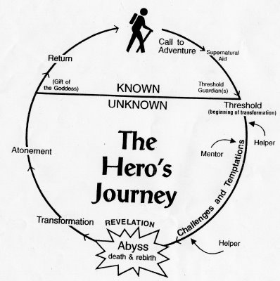

**Joseph Campbell and the Monomyth**

Joseph John Campbell (March 26, 1904 – October 30, 1987) was an American mythology professor, writer, and orator best known for his work in the fields of comparative mythology and comparative religion. As a child, Campbell became fascinated with Native American culture after his father took him to see the American Museum of Natural History in New York where he saw on display featured collections of Native American artifacts. He soon became versed in numerous aspects of Native American society, primarily in Native American mythology. This led to Campbell's lifelong passion for myth and to his study of and mapping of the cohesive threads in mythology that appeared to exist among even dissimilar human cultures.

Campbell relied often upon the writings of Carl Jung as an explanation of psychological phenomena, as experienced through archetypes. But Campbell did not necessarily agree with Jung upon every issue, and had very definite ideas of his own.

A fundamental belief of Campbell's was that all spirituality is a search for the same basic, unknown force from which everything came, within which everything currently exists, and into which everything will eventually return. This elemental force is ultimately “unknowable” because it exists before words and knowledge. Although this basic driving force cannot be expressed in words, spiritual rituals and stories refer to the force through the use of "metaphors" - these metaphors being the various stories, deities, and objects of spirituality we see in the world. For example, the Genesis myth in the Bible ought not to be taken as a literal description of actual events, but rather its poetic, metaphorical meaning should be examined for clues concerning the fundamental truths of the world and our existence.

Accordingly, Campbell believed the religions of the world to be the various, culturally influenced “masks” of the same fundamental, transcendent truths. All religions, including Christianity and Buddhism, can bring one to an elevated awareness above and beyond a dualistic conception of reality, or idea of “pairs of opposites,” such as being and non-being, or right and wrong. Indeed, he quotes in the preface of *The Hero with a Thousand Faces*: "Truth is one, the sages speak of it by many names."

Campbell was fascinated with what he viewed as basic, universal truths, expressed in different manifestations across different cultures. For example, in the preface of *The Hero with a Thousand Faces*, he indicated that a goal of his was to demonstrate similarities between Eastern and Western religions. In his four-volume series of books "The Masks of God", Campbell tried to summarize the main spiritual threads common throughout the world. Tied in with this, was his idea that many of the belief systems of the world which expressed these universal truths had a common geographic ancestry, starting off on the fertile grasslands of Europe in the Bronze Age and moving to the Levant and the "Fertile Crescent" of Mesopotamia and back to Europe (and the Far East), where it was mixed with the newly emerging Indo-European (Aryan) culture.

The role of the hero figured largely in Campbell's comparative studies. In 1949 he introduced his idea of the monomyth, which outlined some of the archetypal patterns Campbell recognized. Heroes were important to Campbell because, to him, they conveyed universal truths about one's personal self-discovery and self-transcendence, one's role in society, and the relationship between the two.

# Archetypes – Carl Jung

An **archetype** is a generic, idealized model of a person, object, or concept from which similar instances are derived, copied, patterned, or emulated. In psychology, an archetype is a model of a person, personality, or behavior. This article is about personality archetypes, as described in literature analysis and the study of the psyche.

In the analysis of personality, the term *archetype* is often broadly used to refer to

1. a stereotype—personality type observed multiple times, especially an oversimplification of such a type; or
2. an epitome—personality type exemplified, especially the "greatest" such example.
3. a literary term to express details.

However, in a strict linguistic sense, an archetype is merely a defining *example* of a personality type. The accepted use of archetype is to refer to a generic version of a personality. In this sense "mother figure" can be considered an archetype and instances can be found in various female characters with distinct (non-generic) personalities.

Archetypes have been present in folklore and literature for thousands of years and appear to be present in prehistoric artwork. The use of archetypes to analyze personality was advanced by Carl Jung early in the 20th century. The value in using archetypal characters in fiction derives from the fact that a large group of people are able to unconsciously recognize the archetype, and thus the motivations, behind the character's behavior.

## Jungian archetypes

The concept of psychological archetypes was advanced by the Swiss psychiatrist Carl Jung. In Jung's psychological framework archetypes are innate, universal prototypes for ideas and may be used to interpret observations. A group of memories and interpretations associated with an archetype is a complex, e.g. a mother complex associated with the mother archetype. Jung treated the archetypes as psychological organs, analogous to physical ones in that both are morphological constructs that arose through evolution.

Jung outlined four main archetypes:

* The [Self](http://en.wikipedia.org/wiki/Self_%28Jung%29), the regulating center of the psyche and facilitator of individuation
* The [Shadow](http://en.wikipedia.org/wiki/Shadow_%28psychology%29), the opposite of the ego image, often containing qualities that the ego does not identify with but possesses nonetheless
* The [Anima](http://en.wikipedia.org/wiki/Anima_%28Jung%29), the feminine image in a man's psyche
* The [Animus](http://en.wikipedia.org/wiki/Animus_%28concept%29), the masculine image in a woman's psyche

Although the number of archetypes is limitless, there are a few particularly notable, recurring archetypal images:

* The [Child](http://en.wikipedia.org/wiki/Child_%28archetype%29) -archetype can take the form of a child who displays adult-like qualities giving, for example, wise advice to their friends or vice versa (like the character Raymond in the film *Rain Man*).
* The [Hero](http://en.wikipedia.org/wiki/Hero) - in Greek mythology and folklore, was originally a demi-god, the offspring of a mortal and a deity.Later, hero (male) and heroine (female) came to refer to characters that, in the face of danger and adversity or from a position of weakness, display courage and the will for self-sacrifice, that is, heroism, for some greater good, originally of martial courage or excellence but extended to more general moral excellence.
* The [Great Mother](http://en.wikipedia.org/wiki/Great_Mother) - A mother goddess is a goddess, often portrayed as the Earth Mother, who serves as a general fertility deity, the bountiful embodiment of the Earth.
* The [Wise old man](http://en.wikipedia.org/wiki/Wise_old_man) - This kind of character is typically represented as a kind and wise, older father-type figure who uses personal knowledge of people and the world to help tell stories and offer guidance that, in a mystical way, may impress upon his audience a sense of who they are and who they might become, thereby acting as a mentor. He may occasionally appear as an absent-minded professor, losing track of his surroundings because of his thoughts. The wise old man is often seen to be in some way "foreign", that is, from a different culture, nation, or occasionally, even a different time, than those he advises. In extreme cases, he may be a being such as Merlin, who was only half human. In medieval chivalric romance and modern fantasy, he often appears as a wizard.In the same works, he can also feature as a hermit, who often explained to the knights -- particularly those searching for the Holy Grail -- the significance of their encounters.
* The [Trickster](http://en.wikipedia.org/wiki/Trickster) or Fox - In mythology, and in the study of folklore and religion, a **trickster** is a god, goddess, spirit, man, woman, or anthropomorphic animal that plays tricks or otherwise disobeys normal rules and norms of behavior. It is incarnated as a clever, mischievous man or creature, who tries to survive the dangers and challenges of the world using trickery and deceit as a defense. For example many typical fairy tales have the King who wants to find the best groom for his daughter by ordering several trials. No brave and valiant prince or knight manages to win them, until a poor and simple peasant comes. With the help of his wits and cleverness, instead of fighting, he evades or fools monsters and villains and dangers with unorthodox manners. Therefore the most unlikely candidate passes the trials and receives the reward. More modern and obvious examples of that type are Brer Rabbit, Bugs Bunny and The Tramp (Charlie Chaplin).
* The [*Puer Aeternus*](http://en.wikipedia.org/wiki/Puer_Aeternus) (Latin for "eternal boy") - examples of the puer archetype include the child, young boy or adolescent. The term can also be applicable to females in which case the Latin term is puella aeterna. Analytical psychologists suggest that some of the signs of the expression of the puer archetype in a person's life can include immaturity, narcissism, and a desire to escape into fantasy or idealism in preference to remaining with the reality of a situation.
* The [artist-scientist](http://en.wikipedia.org/wiki/Artist-scientist) - the artist-scientist is an abstraction of life and the human mind. They are a builder, an inventor, a seeker, a dreamer, and a thinker. Distracted by their own thoughts, they frequently have to be pulled in out of the rain. They are simultaneously vastly knowledgeable and yet innocent, impulsive yet cautious. They represent the wonder to be found in curiosity, and the dangers. Examples: Mr. Spock in *Star Trek*, Doc Emmett Brown in *Back to the Future*, Victor Frankenstein. The artist-scientist represents many things:
  1. The Power of the Mind
  2. Infinite Creativity
  3. Childlike wonder at the world
  4. Boundless Curiosity
  5. The finding of solutions in unexpected ways
  6. Intuitive Improvisation
  7. The danger of ignoring one’s own emotions
* The Scarlet Women – the “fallen woman” archetype in which women are not just told to be sexual and shameless, but told that if they're not they will be punished with a bad reputation, cast out from everything. They're not encouraged to be libertines, they're ordered to be. It's presumed that they will have great difficulty letting go of old modesty, and they're castigated for it.

## Archetypes in literature

Archetypes can be found in nearly all forms of literature; with their motifs being predominantly rooted in folklore. This is evident in such characters as Neo, the nearly godlike hero of *The Matrix*. He is reminiscent of Hercules and the Ancient Sumerian character, Gilgamesh, both of whom possessed divine and human traits. Gilgamesh's friend, Enkidu, is the archetypal sidekick character (powerful but often uncivilized or uninitiated in the rules and norms of the myth's social values), which is paralleled by Robin Hood's Little John, Sundance from *Butch Cassidy and the Sundance Kid*, and Chewbacca in *Star Wars*. The latter being an example of one who is from well outside the culture as reflected by his appearance, although he is often the moral center of Han Solo. This does not imply that the film directors borrowed directly from an Ancient Sumerian epic poem, but, rather, these archetypes are perpetuated as a typecasting due to the powerful emotional response they create in an audience who immediately understand the roles assumed by each character. Indeed, the veneration of specific archetypes remains part of our cultural memory. The concepts that comprise archetypes may be rooted in a collective unconscious, as Jung described it, which some scientists believe may be tied to genetic (instinctual) memory.

William Shakespeare is known for popularizing many archetypal characters that hold great Eurocentric (chiefly British) social importance such as Hamlet, the self-doubting hero and the initiation archetype with the three stages of separation, transformation, and return; Falstaff, the bawdy, rotund comic knight; Romeo and Juliet, the ill-fated ("star-crossed") lovers; Richard II, the hero who dies with honor; and many others. Although Shakespeare based many of his characters on existing archetypes from fables and myths (e.g., Romeo and Juliet on *Pyramus and Thisbe*), Shakespeare's characters stand out as original by their contrast against a complex, social literary landscape. For instance, in *The Tempest*, Shakespeare borrowed from a manuscript by William Strachey that detailed an actual shipwreck of the Virginia-bound 17th-century English sailing vessel *Sea Venture* in 1609 on the islands of Bermuda. Shakespeare also borrowed heavily from a speech by Medea in Ovid's *Metamorphoses* in writing Prospero's renunciative speech; nevertheless, the unique combination of these elements in the character of Prospero created a new interpretation of the sage magician as that of a carefully plotting hero, quite distinct from the wizard-as-advisor archetype of Merlin or Gandalf (both of which may be derived from priesthood authority archetypes from the Bible such as Abraham, Moses, Isaiah, Elijah, etc).

Certain common methods of character depiction employed in dramatic performance rely on the pre-existence of literary archetypes. Stock characters used in theatre or film are based on highly generic literary archetypes. A pastiche is an imitation of an archetype or prototype in order to pay homage to the original creator.

**The Hero’s Journey:**“**A Campbellian Look at the Metaphorical Path to Personal Transformation.” - By Lynne Milum**

**MCj04357890000[1]**

**What is mythology?**

Have you ever contemplated what makes a great story? How is it that humankind has generated so many great stories throughout history? Why does the reader feel aligned with the heroes of these stories in such a way that the stories go beyond the printed word and impact our own lives back here in "the real world"?  
  
While many people believe that myths are stories that are "untrue" or even "lies," in fact, resonant mythologies are metaphors that provide us with symbols of a life we long to experience. To read a myth literally is to miss its higher truth.  
  
Mythological narratives may or may not be based in fact. Myths that are temporal will cease to inspire over time and will die out. The perennial myths, however, are those which persevere and project a timeless truth which point the way to our ultimate destiny. To pursue this destiny is *The Hero’s Journey.***A Campbellian Analysis of the Hero’s Journey**There are three major phases to great stories in mythology, based on Joseph Campbell’s work and documented in ***The Hero with a Thousand Faces.*** These phases are *Separation*, *Initiation* and *Return*. Key story elements as presented by Campbell follow.

**Separation:**Separation is the culmination of a person awakening from a world of drudgery and despair to pursue a higher calling.  
  
The initial step is a **‘Call to Adventure’** where the heroic figure is made aware of a place beyond the world he has known his whole life. A herald is encountered that gives the hero a reason to rethink what he (or she) "knows." This herald usually provides some direction to enter into the adventure and may remain with the hero as a guide.  
  
The hero may refuse the adventure or deny the ability to move beyond the status quo. The heralded event may even be ignored – All of these constitute the **‘Refusal of the Call.’**The use of magical intervention is then needed to plunge the hero into the unknown. The *reluctant hero* requires supernatural forces to urge him on, while the *willing adventurer* gathers amulets (magical items) and advice from the protector as aid for the journey.  
  
A portal or threshold represents the transition into the world of adventure, the step of **‘Crossing the First Threshold.’** A sense of *danger* as well as *opportunity* is conveyed. The threshold guardian or "gatekeeper" must test the hero’s mettle for competency before he may enter the realm. Gatekeepers are terrifying creatures such as Cerberus (the three-headed dog of the Underworld), Pan, ogres, and shape-shifters of classical mythology.  
  
The hero having crossed the threshold is swallowed into the unknown abyss, reborn in the new world, and may appear to those left behind as dead or lost. This may manifest as the hero is swallowed into the darkness and lands in the ‘Belly of the Whale.’ There he awaits rebirth or release from this purgatorial state. His release here symbolizes a relinquishing of attachment to the world left behind.

**Initiation:**Having crossed over into the new realm or escaping the belly of the beast, the hero encounters a series of tests known as **‘The Road of Trials.’** Each task prepares the hero to pursue the ultimate mythological goal. These trials show the hero as moving from childish behaviors to self-reliance. This is his personal evolution from personal limitations to unrealized potential.  
  
The Road of Trials leads to an encounter with the Queen of the World – the **‘Meeting with the Goddess.’** The goddess figure is representative of the Earth Mother or source of life. She may be approachable, as the hero’s mother, sister, beloved, or She may be seemingly larger than life. She is *encompassing beauty*, *unrevealed mystery*, *and unification of good and evil*.  
  
In myth, Woman is the totality of what can be known. As the hero is initiated into life, the goddess becomes transfigured through his understanding. Alas, those with inferior eyes cannot see her magnificence – they may even perceive her as ugly. While the goddess can never be greater than the hero, she always promises more than he can comprehend. The hero can take her as she is and thus be the king of her created world. Through the goddess, the hero attains mastery over life itself. His trials have prepared him to recognize the richness of life that She offers.  
  
The hero may encounter the negative side of woman – **‘Woman as Temptress.’** In this scenario, the hero finds himself occupied with selfish pleasures. The ease with which the hero falls into temptation places the path to enlightenment in peril. While the purified hero will be repulsed by these offerings, the struggling hero must soar beyond the sin and despair, to regain his path.  
  
**Atonement with the Father:** In myth, a parental figure is responsible for guiding the hero through the journey. This representation echoes the need for each person to break free from childhood into adulthood. A father figure may be portrayed as the vengeful male threatened by the rise of the hero and so establishes a horrifying conflict. The hero seeks atonement or "at-one-ment" with the father. Despite a wrathful figure, the hero has faith that The Father is merciful and he must rely on that mercy. In turn, The Father has a change of heart and the fearful image dissolves. The hero is released from the situation through *reconciliation*, *forgiveness* and *mercy*.  
  
Conversely, the father figure may be benevolent, recognizing that as with all life, the cycle must continue. While he assists the hero through his journey, the father figure is mindful that the budding hero is destined to replace him. Just as the mother may be portrayed both as good or evil, so does the above contrast represent the father as a positive and negative force. Our initiation into an adult role in life is contrasted with this dual role of the parent.  
  
The hero’s transformation could be a kind of deification or realization of the essence of life and ultimate purpose – this is his **‘Apotheosis.’** This may be achieved through the conquering of an enemy or the acquisition of supernatural powers. The most far-reaching achievement is that of selflessness, a new ability for unconditional love.  
  
**‘The Ultimate Boon’** is the *benefit*, *favor*, or *blessing* that is bestowed on the hero figure. There is a drive for the hero to share the boon with humankind, whether it is an elixir of immortality, a holy grail, true love, perfect knowledge, or the meaning of life. Most prevalent is the recurring theme of Immortality. The hero achieves illumination that there is an indestructible life beyond the physical body. This Immortality is timeless and experienced in the here and now.

**Return:**On closure of the quest, the hero generally sets off for home to bring the knowledge of his adventure to others. In some cases, the hero does not wish to flee the newfound world – this is his **‘Refusal of the Return.’** He may hold a belief that those still in the former world cannot comprehend what the hero has learned. The hero may take refuge in his immortal bliss accompanied by the Goddess – free from the burdens of ordinary life.  
  
For the hero who accepts the need to return, there are two principal scenarios – *flight* or *rescue*. Where the hero has won blessings, he is commissioned to return to the world to heal it. The protector may assist him on a supernatural return journey or **‘The Magical Flight.’** If the treasure was obtained through conflict or without consent, this will become a flight of difficult obstacles and pursuit by the angered force.  
  
In the second case, the hero requires the outside world to pull him back from the adventure – this is the **‘Rescue from Without.’** The reluctant hero loses all desire to abandon his bliss, he does not want to take on the burdens of the world. Someone or thing may facilitate his miraculous return from apparent death. An overriding reason is necessary to bring the hero back to the world to save it.  
  
Regardless of how the return is accomplished, a supernatural force is again needed to resolve the final crisis, **‘Crossing the Return Threshold.’** The narrative now brings the hero full cycle – it is his destiny to depart from the mystical world he has discovered, and return to the banalities of life with his bounty. Symbolically, through this adventure, the hero has lost his life (self or ego), but by grace it is returned.  
  
On return, the hero must resolve the Two Worlds – divine and human; known and unknown; yin and yang. The key to understanding the myth is that the two kingdoms are actually one. The unknown is a forgotten dimension of the world we already know. To explore that dimension is the whole deed of the hero. By crossing this final threshold, the hero recognizes that the apparent separation in reality does not exist – and he becomes the **‘Master of Two Worlds.’**What is the result of the journey and return? The last task of the hero is to try and communicate his discoveries and the boon for all humanity. He encounters many incapable of comprehending beyond their physical world. But inevitably, another will hear the message, and arise as the next hero.  
  
Our hero achieves a **‘Freedom to Live’** – that is, the ability to pass freely between realms. The hero is *transfigured* – unencumbered by personal limitations and death holds no power over him. Through his transfiguration, the hero is prepared for at-one-ment. He is a presence benefiting the world as it perpetually renews itself, understanding perfected knowledge is imperishable.

**Seeking A New Mythology**

So it is that this cycle is used throughout history, and is written on the human psyche. Our great stories, songs and works of art follow this heroic path, usually culminating in the accomplishment of a "happy ending" or greater good. The story is familiar to our subconscious, and regularly manifests itself in our dreams, where our identity becomes the hero. And the same cycle has been documented with patients experiencing temporary or permanent madness.  
  
In other words, this "Monomyth" (cycle of mythology) is common to all humanity and is written in the way we think and understand ourselves. Mythology is a set of symbols we use to describe our purpose and what each one of us is capable of achieving. Our great religions, social structures and, yes, even our best stories, all achieve the major elements of this cycle  
  
One key characteristic of the monomyth is to recognize the boundaries of our lives and create anticipation of what lies beyond. In days of old, boundaries were represented in the tribe or kingdom, with that beyond to be conquered. The social values and belief systems of the times are contextualized by these boundaries.  
  
In our modern world, where news is instantaneous, language is of minor limitation, and technology allows us to go where no one has gone before – boundaries take on a new nature. Where do our human limitations end? As alluded to above, all humanity faces limitations in time and ability to release from ego. Our hope and salvation is in surpassing those limitations in our individual journey. A new mythology for our times is evolving. Can you see it?

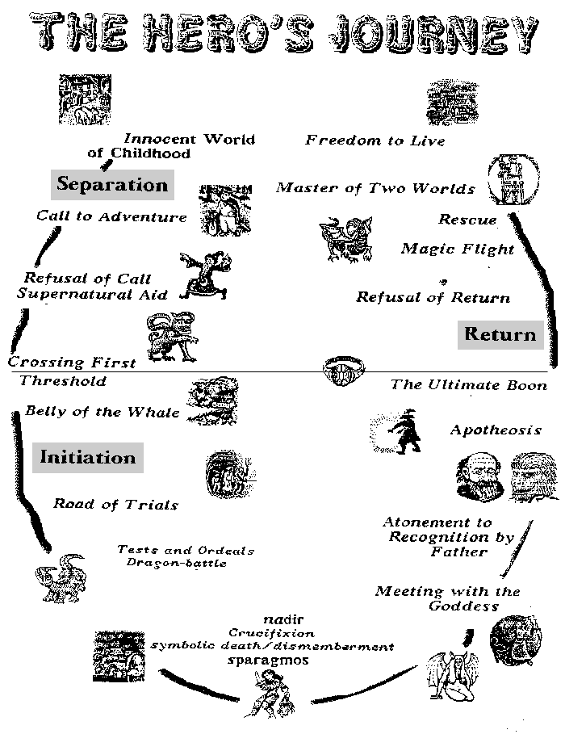

# Hero's Journey (Monomyth): Star Wars, George Lucas and *Harry Potter*

*Star Wars* (1977) is George Lucas' interpretation of the **Hero's Journey** (Monomyth) structure.

The *Star Wars* structure is often attributed to Joseph Campbell's **Hero's Journey**, yet an analysis of *Star Wars* yields far more common story structure elements than noted by Joseph Campbell.

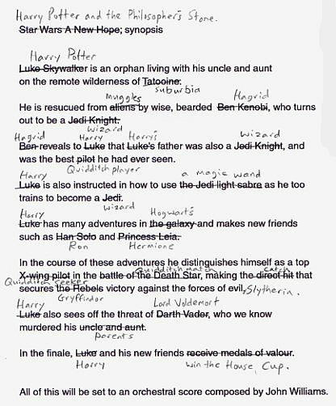

*English 10H*

*Date______________*

Due Date_______________

**Hero Cycle Assignment**

Directions: For this assignment, you will choose a movie from those listed below. You will then watch that movie (I’d suggest 2 or 3 times minimum). Then, you will write an *essay outline* that does the following: discusses and explains how this movie fits into the idea of the “Hero’s Journey” -- you should discuss the ways that the hero of your movie does and does not follow the three stages of the hero’s journey according to Joseph Campbell (Separation, Initiation, Return); this section should make use of *specific details* from the movie to demonstrate how the hero does these things.

Sample essay outline format:

P1 = Introduction with thesis statement

P2 = **The Separation**

1. Call to Adventure
2. Refusal of the Call / Supernatural Aid
3. Crossing the First Threshold / Belly of the Whale

P3 = **The Initiation**

1. Road of Trials
2. Meeting with Goddess / Woman as Temptress
3. Atonement with Father
4. Apotheosis
5. Ultimate Boon

P4 = **The Return**

1. Possible Refusal of Return
2. Magical Flight / Rescue from Without
3. Crossing Return Threshold
4. Master of Two Worlds
5. Freedom to Live

P5 = Conclusion

List of possible movies that you can use:

*Shrek*

*Lord of the Rings trilogy*

*Harry Potter series*

*Rocky*

*The Wizard of Oz*

*Labyrinth*

*Iron Man*

*Batman Begins*

*Back to the Future*

*Indiana Jones and the Last Crusade*

*Superman (1978)*

*Finding Nemo*

*Clash of the Titans*

*Spiderman*

*The Matrix*

*Disney’s Hercules*

*Aladdin*

*Legend*

*Pan’s Labyrinth*

*If you would like to choose a movie that is not on this list, please come to see me.