11AP Lang. & Comp.
Pathos
Pathos is an appeal to emotions, values, desires, and hopes, on the one hand, or fears and prejudices, on the other. Although an argument that appeals exclusively to the emotions is by definition weak – it’s generally propagandistic (the spread of ideas and information to further a cause; in its negative sense, propaganda is the use of rumors, lies, disinformation, and scare tactics in order to damage or promote a cause) in purpose and more polemical (hostile; an aggressive argument that tries to establish the superiority of one opinion over all others) than persuasive – an effective speaker or writer understands the power of evoking an audience’s emotions by using such tools as figurative language, personal anecdotes, and vivid images.
In his farewell speech, Lou Gehrig uses the informal first person (“I”) quite naturally, which reinforces the friendly sense that this is a guy who is speaking on no one’s behalf but his own. He also chooses words with strong positive connotations (meanings or associations that readers have with a word beyond its dictionary definition, or denotation; can be positive or negative; can greatly affect the author’s tone): “grand,” “greatest,” “wonderful,” “honored,” and “blessing.” He uses one image – “tower of strength” – that may not seem very original but strikes the right note. It is a well-known description that his audience understands – in fact, they have probably used it themselves. But of course, the most striking appeal to pathos is the poignant contrast between Gehrig’s horrible diagnosis and his public display of courage.
Sample:
Context: As a vice-presidential candidate, Richard Nixon gave a speech in 1952 defending himself against allegations of inappropriate use of campaign funds. In it, he related this anecdote, which is the reason that the speech will forever be known as “the Checkers speech.” Read this excerpt and note/highlight where and how he appeals to the audience’s emotions.
From “The Checkers Speech”
RICHARD NIXON
One other thing I probably should tell you, because if I don't they will probably be saying this about me, too. We did get something, a gift, after the election. A man down in Texas heard Pat [his wife] on the radio mention the fact that our two youngsters would like to have a dog, and, believe it or not, the day before we left on this campaign trip we got a message from Union Station in Baltimore, saying they had a package for us. We went down to get it. You know what it was? It was a little cocker spaniel dog, in a crate that he had sent all the way from Texas, black and white, spotted, and our little girl Tricia, the six year old, named it “Checkers.” And you know, the kids, like all kids, loved the dog, and I just want to say this, right now, that regardless of what they say about it, we are going to keep it.
Notes:

1. Images and Pathos
You can often appeal to pathos by using striking imagery in your writing, so it’s no surprise that images often serve the same purpose. A striking photograph, for example, may lend an emotional component that greatly strengthens an argument. Advertisers certainly make the most of photos and other visual images to entice or persuade audiences.
Example:
This poster appeared in both the New York Times and the New Yorker magazine in 2000. In what ways does the American Civil Liberties Union (ACLU) appeal to pathos in this advertisement?
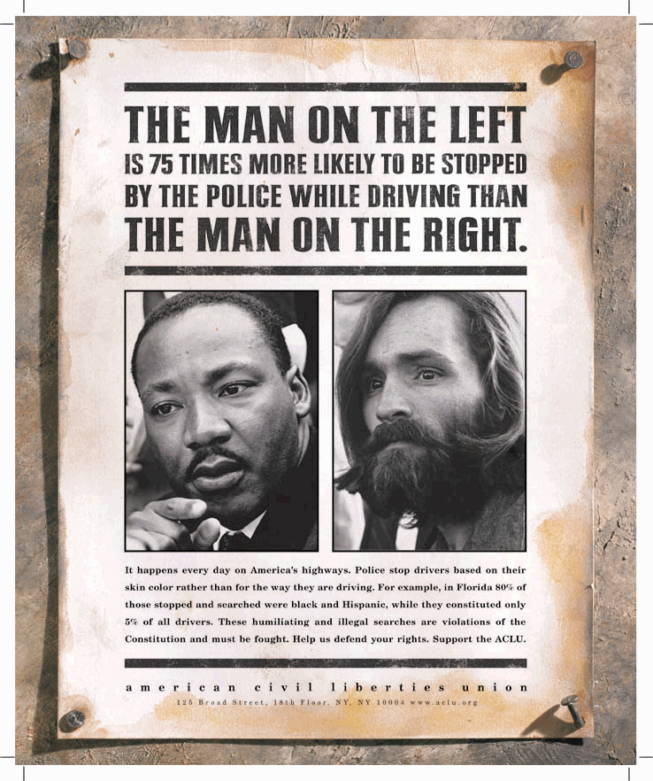
*The headline below the picture reads:
It happens every day on America’s highways. Police stop drivers based on their skin color rather than the way they are driving. For example, in Florida 80% of those stopped and searched were black and Hispanic, while they constituted only 5% of all drivers. These humiliating and illegal searches are violations of the Constitution and must be fought. Help us defend your rights Support the ACLU.
Notes:

2. Humor and Pathos
Another way to appeal to pathos is through humor. Since we like to hear things that we already believe are true, our first reaction to anything that challenges our beliefs is often negative: we think “that’s all wrong!” and get defensive or outright offended. Humor works rhetorically by wrapping a challenge to our beliefs in something that makes us feel good – a joke – and thus makes us more receptive to the new idea.
This goes not just for new ideas, but for the people who are presenting these ideas. Whether it is gentle tongue-in-cheek teasing or bitter irony, humor may help a writer to make a point without, for instance, to preach to the audience or take himself or herself too seriously.

ACTIVITY:
Political commentator Ruth Marcus employs gentle humor in the following essay from 2010 in which she addresses the speaker of the House of Representatives and objects to the members of Congress using electronic devices during hearings and other deliberations. Read the following excerpt and after, analyze the following elements of the passage:
- Structure
- Title
- Tone
- Establishment of ethos
- Establishment of pathos through humor

From “Crackberry Congress”
RUTH MARCUS
Mr. Speaker, please don't.
Go ahead, if you must, and cut taxes. Slash spending. Repeal health care. I understand. Elections have consequences. But BlackBerrys and iPads and laptops on the House floor? Reconsider, before it's too late.
The current rules bar the use of a "wireless telephone or personal computer on the floor of the House." The new rules, unveiled last week, add three dangerous words. They prohibit any device "that impairs decorum."
In other words, as long as you've turned down your cellphone ringer and you're not strolling around the floor chatting with your broker or helping the kids with their homework, feel free to tap away.
If the Senate is the world's greatest deliberative body, the House is poised to be the world's greatest tweeting one.
A few upfront acknowledgements. First, I'm not one to throw stones. I have been known to sneak a peek, or 10, at my BlackBerry during meetings. For a time my daughter had my ringtone set to sound like a squawking chicken; when I invariably forgot to switch to vibrate, the phone would cluck during meetings. In short, I have done my share of decorum impairing.
Second, let's not get too dreamy about the House floor. John Boehner, the incoming speaker, once passed out campaign checks from tobacco companies there. One of his former colleagues once came to the chamber with a paper bag on his head to dramatize his supposed embarrassment at fellow lawmakers' overdrafts at the House bank. Worse things have happened on the House floor than a game of Angry Birds - check it out! - on the iPad.
Nonetheless, lines have to be drawn, and the House floor is not a bad place to draw them. Somehow, it has become acceptable to e-mail away in the midst of meetings. Even Emily Post has blessed what once would have been obvious rudeness, ruling that "tapping on a handheld device is okay if it's related to what's being discussed."
The larger war may be lost, but not the battle to keep some remaining space in life free of gadgetry and its distractions. I'm not talking Walden Pond - just a few minutes of living the unplugged life. There are places - dinner table, church, school and, yes, the House floor - where multitasking is inappropriate, even disrespectful.

