11AP
Political Cartoons
Steps to consider when analyzing a political cartoon:
- Identify the major components, such as characters, visual details, symbols.
- Identify verbal clues, such as titles, tag lines, date, cartoonist, dialogue.
- Notice the position and size of details within the frame.
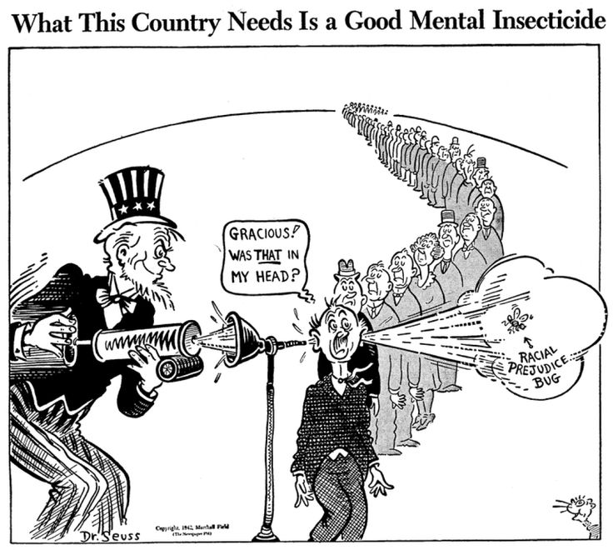
Note: Dr. Theodor Geiss, popularly known as Dr. Seuss, was a prominent political cartoonist during World War II when this cartoon was drawn.

Questions for Analysis:
1. What is the purpose of the political cartoon? (consider the rhetorical triangle)
Primary purpose:

Secondary Purpose:

2. List the details that the cartoonist uses to illustrate and support his primary purpose.

3. List the details used to illustrate and support a secondary purpose.

4. Does the cartoonist indicate that he recognizes alternative viewpoints?

5. If you were to argue against the effectiveness of the argument presented in this cartoon, what fallacy would you point to; what assumption(s) would you challenge?
Fallacy (potential vulnerabilities or weaknesses in an argument):

Assumption(s) (Something taken for granted or accepted as true without proof):

6. Take a position on the issue as it is presented in this political cartoon. Support your position using illustrations and/or data from history, literature, current events, and if appropriate, your own experience.
Personal Position on the issue:

Examples I would use to support my position:

