11AP
Rhetorical Analysis of Visual Texts
Many visual texts are full-fledged arguments. Although the may not be written in paragraphs or have a traditional thesis, they are occasioned by specific circumstances, they have a purpose (whether it is to comment on a current event or simply to urge you to buy something), and they make a claim and support it with appeals to authority, emotion, and reason.
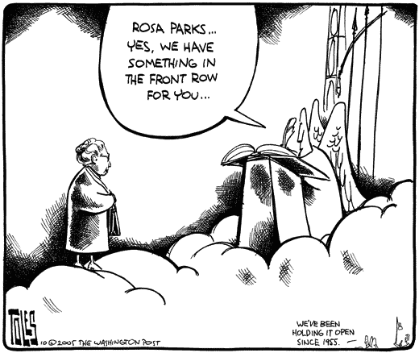
*Tom Toles, a respected and award-winning political cartoonist, drew this after the death of civil-rights icon Rosa Parks in 2006. Parks was the woman who refused to give up her seat on the bus in Montgomery, Alabama; that act came to symbolize the struggle for racial equality in the United States.
We can discuss the cartoon rhetorically, just as we’ve been examining texts that are exclusively verbal.
With a partner, please use SOAPS to analyze the rhetorical situation in this cartoon.

