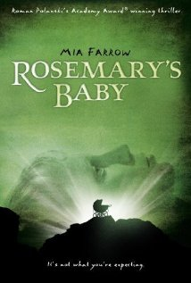
Synopsis:
The 1968 movie Rosemary’s Baby is one of Roman Polanski’s most chilling and acclaimed productions. The film describes the manipulation of a young woman by a high-society occult coven for ritualistic purposes. The movie’s unsettling quality does not rely on blood and gore but on its realistic premise, which forces the viewers to ponder on the likelihood of the existence of elite secret societies. The film was an enormous commercial success, earning over $33 million in the US on a modest budget of $3.2 million. It was met with near universal acclaim from film critics and earned numerous nominations and awards. The American Film Institute ranked the film 9th in their 100 Years...100 Thrills list.
Casting:
Polanski envisioned Rosemary as a robust, full-figured, girl-next-door type, and he wanted actress Tuesday Weld or his own wife, model Sharon Tate for the role. Since the book had not reached bestseller status yet, Evans was unsure the title alone would guarantee an audience for the film, and he felt a bigger name was needed for the lead. Despite her waif-like appearance (which would ultimately prove beneficial, as Rosemary became more frail as her pregnancy progressed), Polanski agreed to cast the young actress Mia Farrow. Her acceptance incensed her then-husband, Frank Sinatra, who had demanded she forgo her career when they wed, and he served her divorce papers via a corporate lawyer in front of the cast and crew midway through filming. In an effort to salvage her relationship, Farrow asked Evans to release her from her contract, but he persuaded her to remain with the project after showing her an hour-long rough cut and assuring her she would receive an Academy Award nomination for her performance.
Robert Redford was the first choice for the role of Guy Woodhouse, but he turned down the offer. Jack Nicholson was considered briefly before Polanski suggested John Cassavetes.
Filming:
One of Mia Farrow's more emotionally charged scenes occurs in the midst of a party, when several of Rosemary's female friends lock Guy out of the kitchen as they console her in private. The scene was shot in a single day. That morning, just before the first take was filmed, a private messenger served Farrow with formal divorce papers from Frank Sinatra. As she read the documents, Farrow fell to her knees on the kitchen floor and openly wept in front of the cast and crew. Roman Polanski insisted that the day be canceled and filming be postponed until the next day, when he would start consecutively filming as many scenes as possible that did not contain Rosemary. Farrow openly refused to accept this, insisting that nothing had changed. The day's filming concluded on time and without delay.
When Farrow was reluctant to film a scene that depicted a dazed and preoccupied Rosemary wandering into the middle of a Manhattan street into oncoming traffic, Polanski pointed to her pregnancy padding and reassured her, "no one's going to hit a pregnant woman". The scene was successfully shot with Farrow walking into real traffic and Polanski following, operating the hand-held camera since he was the only one willing to do it.
Controversy:
Rosemary is representative of the traditional and naive American society of the 50s and 60s – filled with idealism and hope. But that hope was sold, drugged and manipulated by a hidden cult (formed by prestigious and respectable members of society) to forcefully give birth to a new era. Shocking events left indelible marks on the public mind, including the mysterious deaths of JFK, Marilyn Monroe and Martin Luther King; horrific ritual murders perpetrated by MK-Ultra patsies like Charles Manson and Son of Sam caused fear and horror. These events slapped America out of its ideals and forced it to stare at an undefinable, yet tangible force influencing society. Conspiracies and cover-ups made the news and the masses gradually discovered the existence of a shadow government. Disillusionment and cynicism ensued, causing American society to accept or to ignore the true nature of its rulers. Society became the equivalent of Rosemary who has learned of the evil nature of her baby, but nonetheless accepted the responsibility of mothering it. Today’s debased pop-culture is simply the evolution of this system.
1. Less than a year after the release of Rosemary’s Baby, Roman Polanski’s pregnant wife was ritualistically murdered by members of the Charles Manson family. She was stabbed 16 times and her killers wrote the word “pig” in her blood on the wall of her house. According to numerous observers, Manson’s killings were programmed using Beatles songs (Manson himself claimed that the song “Helter Skelter” contained hidden messages intended for his family).
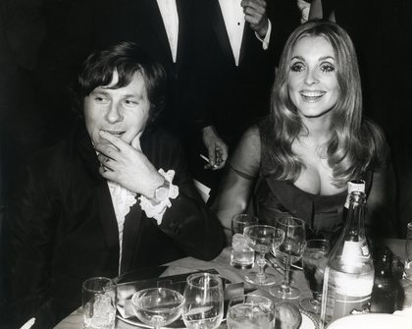
Charles Manson is described by author Fritz Springmeier as “both a Monarch slave and a handler”. According to Springmeier, his programmers knew ahead of time what were going to be the next hits. He was basically used by the elite to carry out ritualistic murders. This horrific event brought a brutal end to the “good vibrations” of the 60s and is viewed by many historians as pivotal moment in American history.
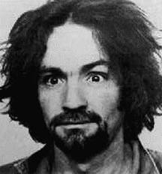
2. The death of John Lennon is another strange piece of the puzzle. The murder occurred as John was walking into the Dakota, the building where Rosemary’s Baby was filmed, and where he was living at the time. Mark David Chapman, the “lone nut” who killed Lennon is heavily suspected to be a Monarch mind-control slave.
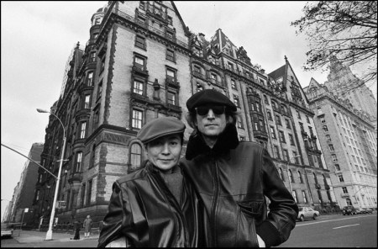
3. Seven years after Tate’s murder, Polanski was arrested and charged with a number of offenses against 13-year-old Samantha Geimer, including rape by use of drugs, perversion, sodomy, lewd and lascivious act upon a child under 14, and furnishing a controlled substance to a minor. According to Geimer’s testimony to the grand jury, Polanski had asked Geimer’s mother (a television actress and model) if he could photograph the girl as part of his work for the French edition of Vogue. After the charges were brought against him, Polanski underwent a court-ordered psychiatric evaluation, and it was expected that he would only receive probation at his sentencing. However, upon learning that he was likely to face imprisonment and deportation, Polanski fled to France in February 1978, hours before he was to be formally sentenced. Since then Polanski has mostly lived in France and avoided visiting countries likely to extradite him to the United States.

Multimedia Study of Horror
Rosemary’s Baby Response Question
Track the use of camera angles and movement throughout the film. Choose 3-4 specific examples to reflect how these scenes (as well as HOW they were filmed) add to the movie’s suspense. BE SPECIFIC. You must use the “Camera Angles” packet in order to help you write this response.
_____________________________________________________________________________________________
_____________________________________________________________________________________________
_____________________________________________________________________________________________
_____________________________________________________________________________________________
_____________________________________________________________________________________________
_____________________________________________________________________________________________
_____________________________________________________________________________________________
_____________________________________________________________________________________________
_____________________________________________________________________________________________
_____________________________________________________________________________________________
_____________________________________________________________________________________________
_____________________________________________________________________________________________
_____________________________________________________________________________________________
_____________________________________________________________________________________________
_____________________________________________________________________________________________
_____________________________________________________________________________________________
_____________________________________________________________________________________________
_____________________________________________________________________________________________
_____________________________________________________________________________________________
_____________________________________________________________________________________________
__________________________________________________________________________________________________________________________________________________________________________________________
_____________________________________________________________________________________________
_____________________________________________________________________________________________
_____________________________________________________________________________________________
_____________________________________________________________________________________________
_____________________________________________________________________________________________
_____________________________________________________________________________________________
_____________________________________________________________________________________________
_____________________________________________________________________________________________
_____________________________________________________________________________________________
_____________________________________________________________________________________________
_____________________________________________________________________________________________
_____________________________________________________________________________________________
_____________________________________________________________________________________________
_____________________________________________________________________________________________
_____________________________________________________________________________________________
_____________________________________________________________________________________________
_____________________________________________________________________________________________
_____________________________________________________________________________________________
_____________________________________________________________________________________________
_____________________________________________________________________________________________
_____________________________________________________________________________________________
_____________________________________________________________________________________________
_____________________________________________________________________________________________
_____________________________________________________________________________________________
_____________________________________________________________________________________________
_____________________________________________________________________________________________
_____________________________________________________________________________________________
_____________________________________________________________________________________________
_____________________________________________________________________________________________
_____________________________________________________________________________________________
_____________________________________________________________________________________________
_____________________________________________________________________________________________
_____________________________________________________________________________________________
_____________________________________________________________________________________________
_____________________________________________________________________________________________
_____________________________________________________________________________________________
_____________________________________________________________________________________________
_____________________________________________________________________________________________
_____________________________________________________________________________________________
_____________________________________________________________________________________________
__________________________________________________________________________________________________________________________________________________________________________________________
_____________________________________________________________________________________________
_____________________________________________________________________________________________
_____________________________________________________________________________________________
_____________________________________________________________________________________________
_____________________________________________________________________________________________
_____________________________________________________________________________________________
_____________________________________________________________________________________________
_____________________________________________________________________________________________
_____________________________________________________________________________________________
_____________________________________________________________________________________________
_____________________________________________________________________________________________
_____________________________________________________________________________________________
_____________________________________________________________________________________________
_____________________________________________________________________________________________
_____________________________________________________________________________________________
_____________________________________________________________________________________________
_____________________________________________________________________________________________
_____________________________________________________________________________________________
_____________________________________________________________________________________________
_____________________________________________________________________________________________

