'The Silence of the Lambs' Revisited: The True Story of Hannibal Lecter and Buffalo Bill
February 14th, 2011
by Eric Larnick (EW.com)
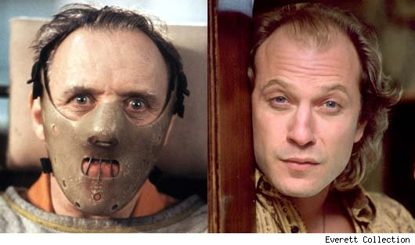
Most people think of February 14 as Valentine's Day, but if you're not the romantic type, you'll be happy to know that this date has another cause for celebration: It was on this day 20 years ago that 'The Silence of the Lambs' opened in theaters. The blockbuster made hundreds of millions of dollars and won scores of major awards, becoming the only horror film to win the Oscar for Best Picture. It also dominated the four other major categories: Actor, Actress, Director, and Screenplay.
Even more impressive for the film's accomplishments, however, is the dark story at the heart of the film. Rarely has pop culture centered around a character as twisted as Hannibal Lecter, the cannibalistic prisoner who offers to help young FBI agent Clarice Starling (Jodie Foster) on a serial-killer case, albeit through strong psychological manipulation. Just as depraved was the criminal Starling was pursuing during the film, Jame Gumb, aka Buffalo Bill, whose horrific method of kidnapping and murdering women shocked and disturbed audiences when they saw the film in 1991. But not everyone realizes that the strange movie characters were based on real people.
As we look back on the film's 20th anniversary, EW.com examines the true-crime history of 'The Silence of the Lambs.'
The True-Crime Story
Thomas Harris was moved to write the novel that inspired the film after meeting FBI agent John E. Douglas, one of the godfathers of criminal profiling. While attending the lecture of the decorated special agent, Harris learned about three notorious serial killers: Ted Bundy, Gary M. Heidnik and Ed Gein. These vile men shaped the character Buffalo Bill.
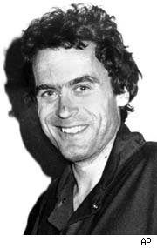
Ted Bundy
Ted Bundy remains one of the most infamous figures in American history -- not surprising, considering that he killed at least 30 people between the years 1974 and 1978. Harris had attended a portion of Bundy's 1979 murder trial in Miami, and later even sent him a copy of his first book in the Lecter series, 'Red Dragon.' It makes sense, then, that Bundy influenced the characters of both Buffalo Bill and Hannibal Lecter.
Like Buffalo Bill, part of Bundy's modus operandi was to pretend to be injured, usually wearing an arm brace, and to ask for help from his unsuspecting victim. And like Lecter, Bundy had an interesting relationship with a criminal investigator. His contact was Robert Keppel, a homicide detective who had achieved national attention as being one of the men who had helped track him down in the midst of his cross-country murdering spree. Keppel was serving as the chief consultant to the task force for the unsolved Green River Murders when he was contacted by Bundy from his Florida holding cell; Bundy offered to help form a profile to help catch the Green River Killer. While working with Bundy ultimately provided little help, Keppel was able to get him to confess to several more unsolved murders. Bundy was executed in 1989, while the Green River Killer -- Gary Ridgway -- was finally apprehended in 2001.
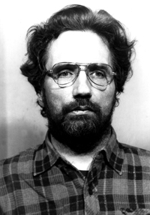
Gary M. Heidnik
Like Buffalo Bill, Gary Heidnik held his prisoners captive under grisly circumstances. John Douglas recalled: "He kept women in a pit about five and a half feet deep. His lawyers argued that he was insane, but he had over half a million dollars in his bank account. He selected stocks with his little disability check through Merrill Lynch. So Merrill Lynch testified, 'We would like to say it was through our strategy that he got so much money, but he did this on his own.'" All told, Heidnik kidnapped, tortured and killed six women in his Philadelphia basement.
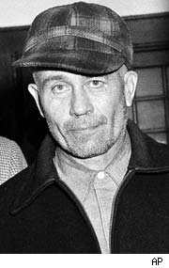
Ed Gein
Perhaps the most notorious influence on 'Silence of the Lambs' was Wisconsin farmer Ed Gein. Although he only confessed to two murders in his lifetime, Gein shocked the nation in 1957 when police raided his house to discover numerous desecrated body parts, including some used as wardrobe and furniture, while other parts were stored as food. Over the course of six years, Gein robbed the graves of freshly buried middle-aged women -- women that he thought resembled his mother -- and took them home to tan their skins, and then cut them up.
Gein was raised by his mother, an abusive Lutheran who taught him daily that women were instruments of the devil. He and his brother were kept from other children during adolescence; after his father and brother passed, his only company in life was his mother, until she died from a stroke in 1945. After her passing, Gein decided that he wanted to become a woman, and began collecting the body parts, in hopes of building a "woman suit" that he could wear. Gein was found legally insane, and spent the rest of his life in a mental institution.
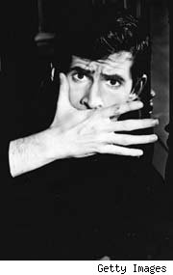
The crimes of Ed Gein influenced the creation not just of Buffalo Bill but also of Norman Bates, in both the novel and in Alfred Hitchcock's seminal adaptation 'Psycho.' Robert Bloch, the author of 'Psycho,' lived only 35 miles away from Gein, and published the book two years after the case. Owing to the nature of the times, the details of Gein's crimes were not published in the news, and Bloch based the character of Bates on the circumstances of the case. He later remarked that he was shocked to discover "how closely the imaginary character I'd created resembled the real Ed Gein both in overt act and apparent motivation." Gein's necrophiliac tendencies also served as the inspiration for Leatherface in 'The Texas Chainsaw Massacre.'
Playing the Part of "Buffalo Bill"
The highly controversial part of Buffalo Bill was played in the film by character actor Ted Levine. Levine told the Chicago Reader: "I scared them to death in the audition. I had no idea what I was going to do. I read the script; I read the book; I tried stuff." Producer Ed Saxon recalled: "There was a sense of watching the real thing, of the guy who was really trying to keep everything under control. In that audition Ted was Gumb. It got kind of electric."
In addition to researching several profiles of serial killers, Ted Levine also frequented transvestite bars, interviewing the patrons to get a better understanding of Bill's transgender behavior. In a weird twist of fate, Jonathan Demme shot Bill's portions of the film in Levine's own hometown of Belaire, Ohio. During filming, Levine got along so well with his kidnap victim -- played by Brooke Smith -- that Jodie Foster's on-set nickname for her was "Patty Hearst."
The most notorious moment of Bill's on-screen career almost didn't happen. In keeping with his fascination of moths and re-emerging from their cocoons, Bill's cross-dressing nude dance was an important moment of character insight in Thomas Harris' original novel. However, it was cut from the screenplay, and would have never been filmed if Levine himself hadn't insisted it be included; he thought the scene was a defining moment for the character. To prepare for the scene, Levine said, "I took a couple shots of tequila."
Impact
With the release of 'Silence,' the film was protested by members of the LGBT community for its negative portrayal of a transgender character. In the original book, a discussion between the FBI and a sex-reassignment surgeon explains that Bill only believes himself to be a transsexual, but that scene was cut in the adaptation of the film (though a version of it exists on the DVD).
After filming, Levine said: "It was hard. I'll never do a character like this again." Levine has since worked to take on more heroic roles to avoid being typecast, most notably playing the part of Capt. Stottlemeyer on the detective show 'Monk.'
Buffalo Bill has one odd legacy in pop culture -- the character served as the inspiration for Seth Green's Chris Griffin on 'Family Guy.'
Hannibal Lecter: Based on a True Story?
As for the man that aided Clarice Starling in capturing Buffalo Bill, the origin of his twisted character has never been fully revealed. Several authors have theorized that Lecter was based on several serial killers throughout the last century.
Thomas Harris rarely grants interviews and has never officially explained where the inspiration came from. But according to his mentor John Douglas, "A lot of people who deal with criminals and who are making decisions for probation and parole don't want to know about the crime. What I've always said is, 'To understand the artist, you must look at the art work.' Harris saw this kind of stuff. And then what he did was he took a composite. Hannibal Lecter does not really exist. There is no one, thank goodness, like him.”

