Sound Effects:
http://nofilmschool.com/2013/11/why-hearing-stuff-is-scarier-than-actually-seeing-stuff
http://blog.nuraypictures.com/the-science-of-sound-horror-film-sound-design/
http://www.academia.edu/1510776/Music_and_sound_in_the_horror_film_and_why_some_modern_and_avant-garde_music_lends_itself_to_it_so_well
http://newsfeed.time.com/2012/06/19/why-is-scary-music-scary-heres-the-science/
Waterphone: https://www.youtube.com/watch?v=9d1yDCWicf0
Director John Carpenter, who creates and performs the music for almost all of his own films, agrees that the soundtrack should be implicit. ''[Y]ou shouldn't be aware of what I'm doing. Yeah, when it's scary or action-filled, you'll hear it, and it's fine. But you shouldn't be sitting there listening to music, or aware of it. It should be working on you. ... I don't want you to be aware ofthe technique. I just want you to feel it'' (Droney 118).
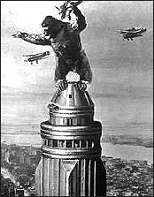
Sometimes the composer does want you to be aware of his technique. The most obvious soundtrack technique, known as''mickeymousing,'' is just barely considered respectable by respectable film composers. Mickeymousing is when the music blatantly matches the action. When King Kong climbs the Empire State building, the music likewise rises and falls with each of his movements. In what has become a cliché, mickeymousing even has the music giving away the action about to happen(Bazelon 24). A heavy brass chord announces danger; a low, sustained tone creates mystery; sliding intervals of gliding strings imply seductiveness. This musical signal, that prepares the audience for the dramatic events to follow, is known as the stinger.
Synthesizers are almost always used in SF and horror films because they can produce otherworldly sounds.
The length of a sound from its beginning to its peak is called attack, which may be fast (like a door slamming) or slow (like a dog growling). Fast attack sounds loud. Loud sounds are more frightening than soft sounds, and sudden loud sounds are the most frightening of all. If you are shooting a scene about a woman alone in a house on a stormy night and you want to show how terrified she is of the situation, one way is to use loud claps of thunder. When old radio mystery shows wanted to suggest
someone alone in a dark house with a killer on the loose, what did they use? Sounds with eerie attack. The ticking clock, the thunder and rain beating against the window, the howling wind, the shutters banging against the side of the house, and -- creepiest of all -- the sound of steps coming slowly up the creaking stairs. These are still very popular in films today, not because we need the audio clues, but because they are such familiar shorthand for this clichéed but still exciting situation.
Though horror films can often feature supernatural creatures and events, ironically enough what they need is an uncomplicated sound that will disturb the audience viscerally rather than interest them intellectually. You might think I'm talking about sound effect libraries, of wolves growling or boots stalking down an alleyway -- and you're right, soundtracks do use these. But they also use much more mundane sounds. For instance, the sound studios of horror movies are frequently littered with fruits and vegetables to make various body-snapping sound effects.

“Ever wondered why the music in horror films scares us? The harsh sounds tap into instinctive fears”
By DAVID DERBYSHIRE FOR MAILONLINE
UPDATED: 04:13 EST, 26 May 2010

From the screeching violins of Psycho to the crashing chords of Jaws, film-makers have long relied on disturbing soundtracks to heighten suspense and terror.
Now, scientists think they know why the music used in scary movies is so good at making our flesh creep.
They have shown that the harsh, discordant and unexpected sounds used in horror soundtracks imitate the screams of frightened animals.
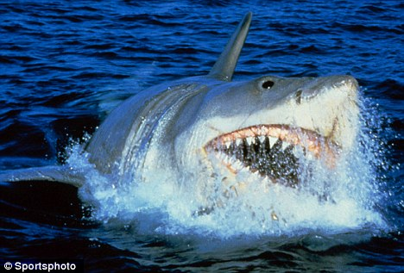
The crashing chords of Jaws tap into deep, instinctive fears
By peppering chillers with these noises, movie makers are tapping into deep, instinctive fears, they say.
The study looked at a class of noises called 'non-linear' sounds.
These range from the sort of distorted notes that come from a hi-fi cranked up too high, to the squeal produced by blowing too hard into a trumpet.
Prof Daniel Blumstein, who led the study at the University of California, Los Angeles, studied the soundtracks of 102 of the world's most popular movies - from war films and dramas, to horror movies and adventure romps.
The study - which involved composer Peter Kaye at Kingston University, London - looked at the music in films, as well as special effects and screams.
The analysis showed that horror films had the most noisy female screams - while adventure films had the most screams from men.
Horror films also had an higher than expected number of abrupt shifts up and down in pitch, he reported in the Royal Society journal Biology Letters.
Dramatic films had fewer than expected screams and lower pitched sounds than other genre of movie.
The study concluded that the use of these non-linear sounds was not random - but used to 'enhance the emotional impact of scenes'.
'Non-linearities are commonly produced when animals are under duress, such as the fear screams produced when animals are attacked by predators,' he said.
'In mammals, and possibly also in birds, when you push too much air through your larynx you produce these non-linear sounds and its a pretty unbluffable signal of fear,' he added.
'It may be that film makers intuitively realise that they can use these types of sounds.'

