TONE CHART
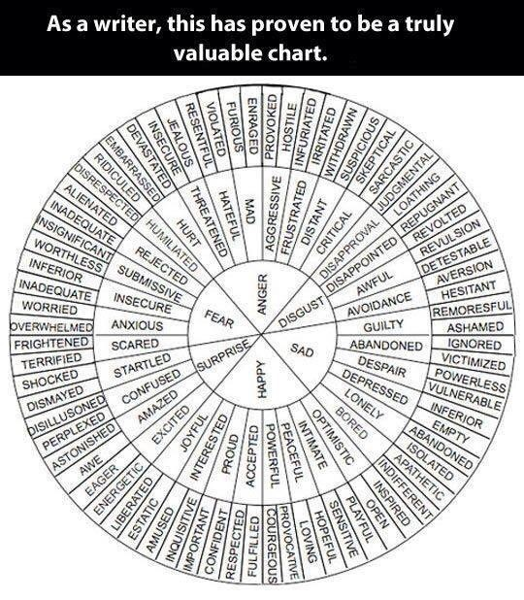
- Skip Nicholson

