11AP
Analyzing Visual Rhetoric
The following advertisement is from the World Wildlife Fund (WWF), a conservation organization that “combines global reach with a foundation in science, involves action at every level from local to global, and ensures the delivery of innovative solutions that meet the needs of both people and nature.”
Please answer the following questions:
1. What rhetorical strategies does the WWF use to achieve its purpose in this advertisement? Pay particular attention to the interaction of the written text with the visual elements.
2. How does the arrangement on the page affect your response? How does the WWF appeal to ethos, logos, and pathos?
3. How effective do you think the advertisement is in reaching its intended audience? Explain.

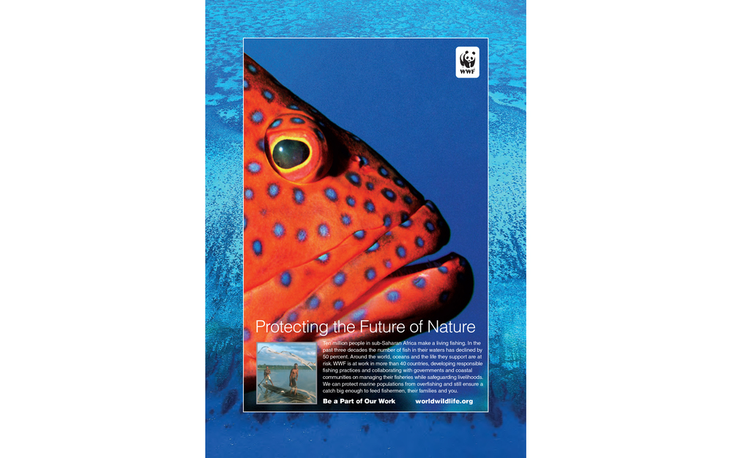
***Please view the picture in its colorful original format at the following link: http://www.maruyamadesignllc.com/wwf/

The text reads:
Protecting the Future of Nature
Ten million people in sub-Saharan Africa make a living fishing. In the past three decades the number of fish in their waters has declined by 50 percent. Around the world, oceans and the life they support is at risk. WWF is at work in more than 40 countries, developing responsible fishing practices and collaborating with governments and coastal communities on managing their fisheries while safeguarding livelihoods. We can protect marine populations from overfishing and still ensure a catch big enough to feed the fisherman, their families and you.
Be Part of Our Work worldwildlife.org

Response:

