Multimedia Study of Horror

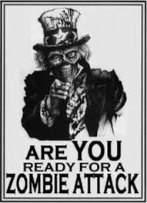

zom•bie
noun \ˈzäm-bē\
: a person who moves very slowly and is not aware of what is happening especially because of being very tired
: a dead person who is able to move because of magic according to some religions and in stories, movies, etc.
: within Haitian religion, zombie (Haitian Creole: zonbi) is an animated corpse raised by magical means, such as witchcraft.
Origins:
Africa
According to the West African tenets of Vodou, a dead person can be revived by a bokor, or sorcerer. Zombies remain under the control of the bokor since they have no will of their own. "Zombi" is also another name of the Vodou snake lwa Damballah Wedo, of Niger–Congo origin; it is akin to the Kikongo word nzambi, which means "god". There also exists within the West African Vodun tradition the zombi astral, which is a part of the human soul that is captured by a bokor and used to enhance the bokor's power. The zombi astral is typically kept inside a bottle which the bokor can sell to clients for luck, healing or business success. It is believed that after a time God will take the soul back and so the zombi is a temporary spiritual entity. It is also said in vodou legend that feeding a zombie salt will make it return to the grave.
The idea of zombies is present in some South African cultures. In some communities it is believed that a dead person can be turned into a zombie by a small child. It is said that the spell can be broken by a powerful enough sangoma.
It is also believed in some areas of South Africa that witches can turn a person into a zombie by killing and possessing the victim's body in order to force it into slave labor. After rail lines were built to transport migrant workers, stories emerged about "witch trains". These trains appeared ordinary, but were staffed by zombie workers controlled by a witch. The trains would abduct a person boarding at night, and the person would then either be turned into a zombie worker, or beaten and thrown from the train a distance away from the original location.
Haiti
In 1937, while researching folklore in Haiti, Zora Neale Hurston encountered the case of a woman who appeared in a village, and a family claimed she was Felicia Felix-Mentor, a relative who had died and been buried in 1907 at the age of 29. However, the woman had been examined by a doctor, who found on X-ray that she did not have the leg fracture that Felix-Mentor was known to have had. Hurston pursued rumors that the affected persons were given a powerful psychoactive drug, but she was unable to locate individuals willing to offer much information. She wrote: "What is more, if science ever gets to the bottom of Voodoo in Haiti and Africa, it will be found that some important medical secrets, still unknown to medical science, give it its power, rather than gestures of ceremony."
Several decades later, Wade Davis, a Harvard ethnobotanist, presented a pharmacological case for zombies in two books, The Serpent and the Rainbow (1985) and Passage of Darkness: The Ethnobiology of the Haitian Zombie (1988). Davis traveled to Haiti in 1982 and, as a result of his investigations, claimed that a living person can be turned into a zombie by two special powders being introduced into the blood stream (usually via a wound). The first, coup de poudre (French: "powder strike"), includes tetrodotoxin (TTX), a powerful and frequently fatal neurotoxin found in the flesh of the pufferfish (order Tetraodontidae). The second powder consists of dissociative drugs such as datura. Together, these powders were said to induce a deathlike state in which the will of the victim would be entirely subjected to that of the bokor. Davis also popularized the story of Clairvius Narcisse, who was claimed to have succumbed to this practice. The most ethically questioned and least scientifically explored ingredient of the powders, is part of a recently buried child's brain.
The process described by Davis was an initial state of deathlike suspended animation, followed by re-awakening — typically after being buried — into a psychotic state. The psychosis induced by the drug and psychological trauma was hypothesized by Davis to reinforce culturally learned beliefs and to cause the individual to reconstruct their identity as that of a zombie, since they "knew" they were dead, and had no other role to play in the Haitian society. Societal reinforcement of the belief was hypothesized by Davis to confirm for the zombie individual the zombie state, and such individuals were known to hang around in graveyards, exhibiting attitudes of low affect.
Davis's claim has been criticized, particularly the suggestion that Haitian witch doctors can keep "zombies" in a state of pharmacologically induced trance for many years. Symptoms of TTX poisoning range from numbness and nausea to paralysis — particularly of the muscles of the diaphragm — unconsciousness, and death, but do not include a stiffened gait or a deathlike trance. According to psychologist Terence Hines, the scientific community dismisses tetrodotoxin as the cause of this state, and Davis' assessment of the nature of the reports of Haitian zombies is viewed as overly credulous.
Scottish psychiatrist R. D. Laing highlighted the link between social and cultural expectations and compulsion, in the context of schizophrenia and other mental illness, suggesting that schizogenesis may account for some of the psychological aspects of zombification.
Slaves brought to Haiti in the 17th and 18th centuries, believed that when they died, Baron Samedi would gather them from their grave to bring them to heaven, unless they had offended him in some way, such as committing suicide, in which case they would be forever a slave after death, as a zombie.
In popular culture
There is no “cannon” way to define a monster. Different authors and cultures have different ideas of the lore, or rules and associated myth, connected to a given creature. Zombies, for example have numerous subcategories, and individual authors differentiate their versions of the creature by writing their unique lore.
Death: human impermanence is a common theme of literature.
-In horror literature it is one of the biggest factors in what we consider monstrous.
-Aberration: Deviation. It becomes “non-normal” to the point of being grotesque. In many cases, this is one of the most terrifying points of a monster.
-The Zombie is literally the walking dead, the ghoul. Not only are they an aberration in that they are undead, but also that they wish to consume the living.
-For this reason, Zombie stories are often a metaphor for society’s status quo destroying the individual (or can be).
As fictional undead creatures, zombies are regularly encountered in horror and fantasy themed works. They are typically depicted as mindless, reanimated corpses with a hunger for human flesh, and particularly for human brains in some depictions. Although they share their name and some superficial similarities with the zombie from Haitian Vodun, their links to such folklore are unclear. Many consider George A. Romero's film Night of the Living Dead to be the progenitor of these creatures. Zombies have a complex literary heritage, with antecedents ranging from Richard Matheson and H. P. Lovecraft to Mary Shelley's Frankenstein, all drawing on European folklore of the undead. The popularity of zombies in movies has led to them sometimes having been taken out of their usual element of horror and thrown into other genres, for example the comedy film Shaun of the Dead. The "zombie apocalypse" concept, in which the civilized world is brought low by a global zombie infestation, has become a staple of modern popular art. By 2011 the influence of zombies in popular consciousness had reached far enough that the United States government's Center for Disease Control used the idea as a theme to promote disaster preparedness.
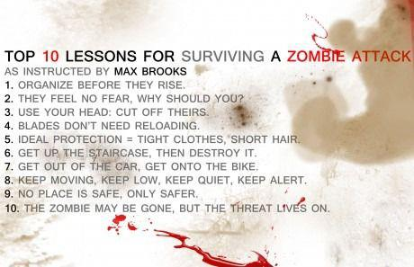

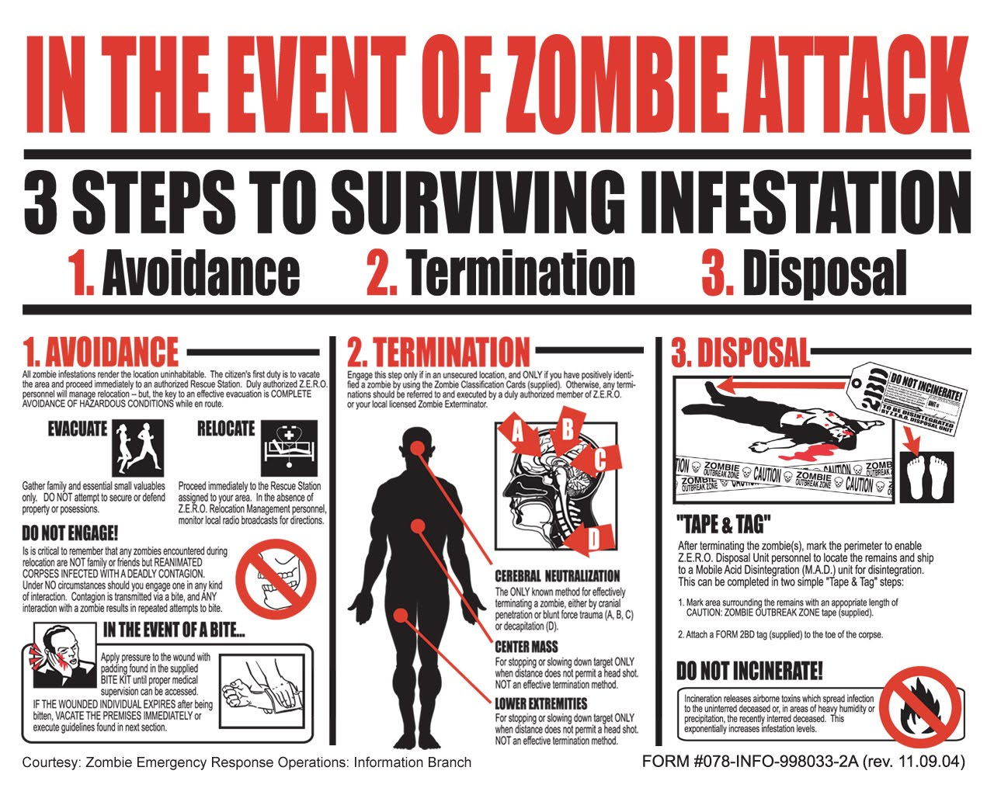
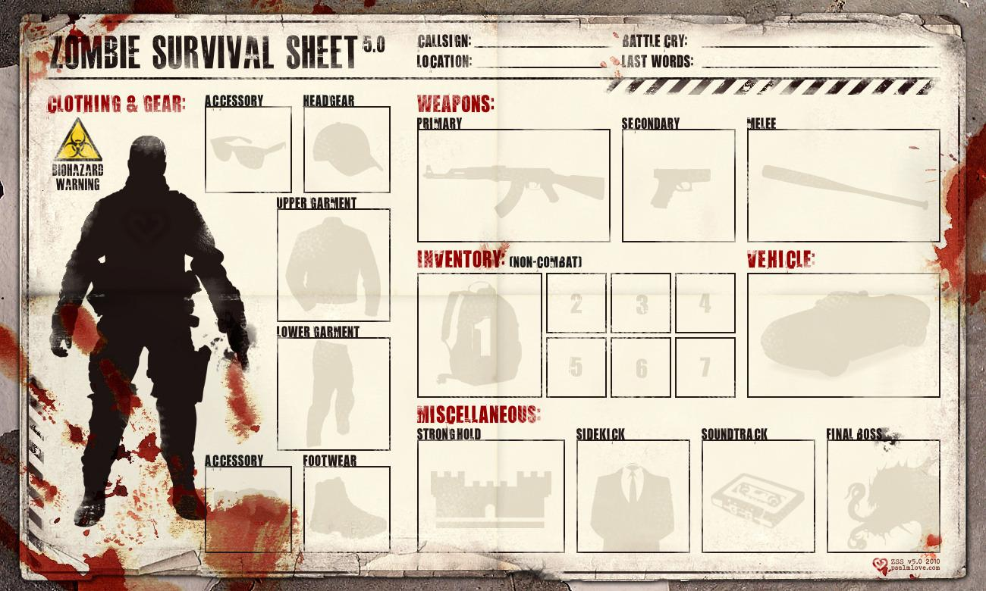
Multimedia Study of Horror
Spring 2014-2015
Zombie Apocalypse!

Well, it’s happened: the dead walk. The members of your peer group are your group of survivors. Regardless of how you came to meet one another, you have decided that your best chance survival is to stick together. Now that that’s decided, how will you survive? What are your plans? Who will be in charge? (Assume that they are Max Brooks-type zombies like we’ve seen in 28 Days Later and/or World War Z; they move purposefully and quickly)

Together, come up with your plan for survival, including:
- Resources: What special skills does each person bring to the group and how will you make use of them?
- Decision Making: Is there a leader? Is it a democracy? How will the group settle disputes?
- Objectives: Will you be merely surviving? Looting? Foraging? Hunting the undead? Where will you take shelter?
- Diplomacy: Do you help other survivors? Do you share supplies? Do you keep to yourselves? What do you do with a wounded teammate?

Remember, these are all just suggestions to get you started, so feel free to add relevant information. As you make your rulings as to how your group will function, justify your rationale: If you’re going to be a team of zombie hunters, why did you make that choice? If you choose to leave behind injured teammates, how do you justify this?

Zombie Links:
“Florida Professor: Zombies Aren’t Real”
http://www.cio.com/article/26134/Fla._Prof_Ghosts_Zombies_Vampires_Really_Aren_t_Real
Cracked.com: “5 Scientific Reasons a Zombie Apocalypse Could Actually Happen”
http://www.cracked.com/article_15643_5-scientific-reasons-zombie-apocalypse-could-actually-happen.html
“Real Zombies”
http://www.youtube.com/watch?v=tIS4t-sF0AQ&feature=related
Jonathan Coulton: “All We Wanna Do Is Eat Your Brains”
http://www.youtube.com/watch?v=S6vnM9I7HIo
“Zombies in Plain English”
http://www.youtube.com/watch?v=bVnfyradCPY
“Tips for Surviving the Zombie Apocalypse with P. Allen Smith”
http://www.youtube.com/user/ehowhome?v=9vNz9RQRt9k
“Zomcon: A Bright New World”
http://www.youtube.com/watch?v=KGx_X3y4Gec
“A Guy’s Guide to Zombies”
http://www.youtube.com/watch?v=_3-bKMpU2-E
“How Do You Decide Where to go in a Zombie Apocalypse?”
http://ed.ted.com/lessons/how-do-you-decide-where-to-go-in-a-zombie-apocalypse-david-hunter

Short multimedia discussion: Zombies in humor
Question to consider: How can something that terrifies us one moment be funny to us the next? What qualities are different between scary monster stories and funny ones?
Presentation Links: http://www.youtube.com/watch?v=Snb_rkKpIFw “Your Brains”- J. Coulton
http://www.youtube.com/watch?v=0N1_0SUGlDQ “Zombies on your Lawn”- L. Shigihara
http://www.youtube.com/watch?v=yfDUv3ZjH2k Shaun of the Dead Trailer
http://www.youtube.com/watch?v=oAnkBwDv-iY Zombieland Trailer

